
COMSATS University Islamabad,
Sahiwal Campus

Asaan Form
(AI-Powered Form Filling System)

A project presented to
COMSATS University Islamabad, Sahiwal Campus

In partial fulfillment
of the requirement for the degree of

Bachelor of Science in Computer Science (2022-2026)

By

Arif Aqeel Ahmad CIIT/FA22-BCS-023/SWL
Hammad Mustafa CIIT/FA22-BCS-031/SWL
M. Asim Ashfaq CIIT/FA22-BCS-061/SWL



COMSATS University Islamabad,
Sahiwal Campus

Asaan Form

By

Arif Aqeel Ahmad | CIIT/FA22-BCS-023/SWL
Hammad Mustafa | CIIT/FA22-BCS-031/SWL
M. Asim Ashfaq | CIIT/FA22-BCS-061/SWL

Supervisor
Aqsa Tehseen

Bachelor of Science in Computer Science (2022-2026)

DECLARATION
We hereby declare that this software, neither whole nor as a part, has been copied out from any source. It is further declared that we have developed this software and accompanied report entirely based on our personal efforts. If any part of this project is proved to be copied out from any source or found to be reproduction of some other, we will stand by the consequences. No portion of the work presented has been submitted for any application for any other degree or qualification of this or any other university or institute of learning.

Arif Aqeel Ahmad Hammad Mustafa M. Asim Ashfaq
------------------------- ------------------------- -------------------------

CERTIFICATE OF APPROVAL
It is to certify that the final year project of BS (CS) “Asaan Form (AI-Powered Form Fillin System)” was developed by Arif Aqeel Ahmad (CIIT/FA22-BCS-023/SWL), Hammad Mustafa (CIIT/FA22-BCS-031/SWL) and M.Asim Ashfaq (CIIT/FA22-BCS-061/SWL) under the supervision of Dr. Muhammad Farhan and that in his opinion it is fully adequate, in scope and quality for the degree of Bachelor of Science in Computer Sciences.

Aqsa Tehseen
Supervisor

Lecturer
Department of Computer Science
COMSATS University Islamabad, Sahiwal Campus

Dr. Zafar Iqbal Roy
Head of Department

Assistant Professor
Department of Computer Science
COMSATS University Islamabad, Sahiwal Campus

Executive Summary

AsaanForm was developed to address inefficiencies in traditional form-processing environments where organizations rely on manual document extraction, paper-based workflows, or disconnected digital tools. These systems often result in slow data processing, high error rates, duplicate entries, and difficulties handling multilingual documents. The project aims to overcome these challenges by providing an intelligent document automation platform that integrates Agentic AI to improve workflow efficiency while maintaining accuracy and transparency.
The system offers a web-based workspace where users can upload unstructured documents such as CNICs, transcripts, and application forms. It automatically extracts, validates, and maps the data into structured form fields. A multilingual AI chatbot powered by Retrieval-Augmented Generation (RAG) helps users by resolving missing information and answering queries. A self-healing mechanism attempts automated verification before requesting human intervention, reducing manual workload. After validation, users can generate finalized PDFs, while role-based access ensures proper workflow control.
AsaanForm uses a modern multi-tier architecture with React.js for the frontend, Node.js/Express for middleware, FastAPI microservices for AI processing, and MongoDB for data storage. The system includes an OCR microservice with bilingual capabilities using PaddleOCR for English and UTRNet/YOLOv8 for Urdu . Document understanding is handled through Docling, while LangGraph agents manage tasks such as intent detection, data mapping, validation, and chatbot interaction using LangChain . A vector database (Milvus/Zilliz Cloud) supports intelligent retrieval, and the system was developed using Object-Oriented Design with iterative testing across all components.
Acknowledgement
All praise is due to Almighty Allah, whose countless blessings, mercy, and guidance made it possible to complete this project successfully. The completion of AsaanForm would not have been possible without the strength, patience, and understanding granted throughout the project journey, especially during the challenging phases of research, design refinement, implementation, and testing.
Sincere gratitude is extended to the project supervisor, Aqsa Tehseen, for her valuable guidance, constructive feedback, and continued encouragement throughout the development of this project. Her academic supervision played a central role in shaping the project direction, improving the system design, and ensuring that the work remained aligned with the objectives of a professional final year project. Gratitude is also extended to the faculty members and Final Year Project Committee of COMSATS University Islamabad, Sahiwal Campus, for their observations, suggestions, and academic support during the evaluation process.
Special thanks are also due to parents, family members, and friends whose moral support, prayers, and encouragement remained a source of motivation during the entire development cycle. Their trust and support helped sustain the effort required to bring this project from concept to implementation. Finally, appreciation is extended to all those individuals whose direct or indirect contribution helped in completing this academic work successfully.

Arif Aqeel Ahmad Hammad Mustafa M Asim Ashfaq

Abbreviations
Abbreviation | Full Form
AI | Artificial Intelligence
API | Application Programming Interface
CNIC | Computerized National Identity Card
SLO | Service Level Objective
DL | Document Loading
OCR | Optical Character Recognition
DFD | Data Flow Diagram
SMTP | Simple Mail Transfer Protocol
OTP | One Time Password
FR | Functional Requirement
CNN | Convolutional Neural Network
LLM | Large Language Model
JWT | JSON Web Token
NLP | Natural Language Processing
NFR | Non-Functional Requirement
OCR | Optical Character Recognition
OOD | Object-Oriented Design
OOP | Object-Oriented Programming
ORM | Object-Relational Mapping
YOLO | You Only Looks Once
RAG | Retrieval-Augmented Generation
RNN | Recurrent Neural Network
UI | User Interface
UML | Unified Modeling Language

Table of Contents

Introduction ..
1 Introduction 1
1.1 Brief 1
1.2 Relevance to Course Modules 2
1.2.1 Software Engineering 2
1.2.2 Object Oriented Programming 2
1.2.3 Database Systems 3
1.2.4 Artificial Intelligence 3
1.2.5 Web Engineering 4
1.2.6 Data Structures and Algorithms 4
1.2.7 Computer Networks 4
1.2.9 Human Computer Interaction 5
1.2.10 Software Quality Assurance 5
1.3 Project Background 6
1.4 Literature Review 6
1.5 Analysis from Literature Review 8
1.6 Methodology and Software Lifecycle 8
1.6.1 Rationale Behind Selected Methodology 8
Problem Definition
2 Problem Definition 11
2.1 Problem Statement 11
2.2 Deliverables and Development Requirements 11
2.2.1 User Interface (UI) Design 12
2.2.2 User Registration and Authentication 12
2.2.3 User Dashboard and Activity History 12
2.2.4 Document Upload and Management 13
2.2.5 Object Detection and Document Region Localization 13
2.2.6 Bilingual OCR and Text Extraction 13
2.2.7 Agentic Fields Mapping and Form Population 13
2.2.8 Form Session Management Module 13
2.2.9 AI Chatbot Integration 14
2.2.10 Extraction Result Review and Correction 14
2.2.11 Notification System 14
2.2.12 External API and Service Integration 14
2.2.13 Web Application Development 15
2.2.14 Documentation 15
2.2.15 Testing and Quality Assurance 15
2.2.16 Maintenance, Updates and Continuous Improvement 16
2.3 Current System 16
Requirement Analysis
3 Requirement Analysis 19
3.1 Use Case Diagrams 19
3.1.1 Use Case Diagram for End User 19
3.1.2 Use Case Diagram for Text Extraction Using OCR 20
3.1.3 Use Case Diagram for Track Processing Status 21
3.2 Detailed Use Case 21
3.3 Functional Requirements 27
3.4 Non-Functional Requirements 33
3.4.1 Usability 33
3.4.2 Performance 34
3.4.3 Security 35
3.4.4 Scalability 35
3.4.5 Reliability 36
3.4.6 Maintainability 37
3.4.7 Browser Compatibility 38
3.4.8 Communication Interfaces 38
Design and Architecture
4 Design and Architecture 44
4.1 System Architecture 44
4.2 Data Representation 46
4.3 Process Flow 48
4.4 Design Models 50
4.4.1 Class Diagram 51
4.4.2 Sequence Diagram for Document Upload 53
4.4.3 Sequence Diagram for Chat(RAG) 54
4.4.4 Sequence Diagram for Form Filling 55
Implementation
5 Implementation 56
5.1 Algorithm 56
5.2 External APIs 57
5.3 User Interface 58
5.3.1 Login Page 58
5.3.2 Signup Page 59
5.3.3 About Page 60
5.3.4 Home Page 61
5.3.5 User Dashboard 62
5.3.6 Upload Form Page 62
5.3.7 Chatbot Page 63
5.3.8 UI Design Summary 64
Testing and Evaluation
6 Testing and Evaluation 71
6.1 Manual Testing 71
6.1.1 System Testing 71
6.1.2 Unit Testing 72
6.1.3 Functional Testing 74
Conclusion and Future Work
7 Conclusion and Future Work 77
7.1 Conclusion 77
7.2 Future Work 78
7.2.1 Mobile Application Development 78
7.2.2 Multi Language and Regional Support 78
7.2.3 Advanced Analytics Dashboard 78
7.2.4 Multi-Language and Regional Support 79

List of Figures

Figure 3.1: Use Case Diagram for End User 20
Figure 3.2: Use Case Diagram for Text Extraction 20
Figure 3.3: Use Case Diagram for Tracking Process Status 21
Figure 4.1: System Architecture for AsaanForm 46
Figure 4.2: Data Representation Diagram of AsaanForm 48
Figure 4.3: Process Flow Representation of AsaanForm 51
Figure 4.4: Class Diagram of AsaanForm 52
Figure 4.5: Sequence Diagram of Document Upload 53
Figure 4.6: Sequence Diagram of RAG System 54
Figure 4.7: Sequence Diagram of Form Filling 56
Figure 5.1: Login Page 59
Figure 5.2: Signup Page 60
Figure 5.3: About Page 61
Figure 5.4: Home Page 61
Figure 5.5: User Dashboard 62
Figure 5.6: Upload Form Page 63
Figure 5.7: AI Chatbot Page 64

List of Tables
Table 1.1: Literature Review 7
Table 3.1 Register User 22
Table 3.2 Upload Document 22
Table 3.3 Extract Bilingual Text 23
Table 3.4:Map Data to Form Fields 24
Table 3.5: Review and Correct Extracted Data 24
Table 3.6: Preview Auto-Filled Form 25
Table 3.7: Use AI Chatbot 25
Table 3.8: Download Completed Form 26
Table 3.9: View Submission History 27
Table 3.10: User Registration and Authentication 27
Table 3.11: Document Upload and Preprocessing 28
Table 3.12: Object Detection and Region Localization 29
Table 3.13: Bilingual OCR Extraction 29
Table 3.14: AI Agent-Based Field Mapping 30
Table 3.15: Form Creation and Management 31
Table 3.16: Automated Form Filling with User Review 31
Table 3.17: Multi-Document Session Support 32
Table 3.18: Usability 34
Table 3.19: Performance 34
Table 3.20: Security 35
Table 3.21: Scalability 36
Table 3.22: Reliability 36
Table 3.23: Maintainability 37
Table 3.24: Browser Compatibility 38
Table 3.25: Communication Interfaces 39
Table 5.1: Details of APIs used in the Project 57
Table 6.1: System Testing Results 71
Table 6.2: User Login 72
Table 6.3: OCR Extraction and Bilingual Processing 73
Table 6. 4: Form Field Mapping and Auto Fill 73
Table 6. 5: User Workflow Functional Testing 74
Table 6. 6: AI Processing Functional Testing 75

Chapter 1

Introduction

Introduction
AsaanForm is a modern AI-driven web application designed to automate the process of digital form completion by integrating Optical Character Recognition, computer vision, and agentic artificial intelligence into a single accessible platform. The system addresses a widespread and persistent inefficiency in how individuals interact with digital forms, particularly in contexts where users must repeatedly extract and re-enter information from their personal documents into institutional or government portals.
Instead of relying on manual data entry across disconnected form interfaces, AsaanForm unifies document upload, intelligent information extraction, and automated field mapping into one coherent workflow supported by a bilingual processing engine and a secure, responsive user interface
The project is especially relevant in the Pakistani context, where citizens regularly interact with forms requiring information drawn from CNICs, academic transcripts, and other identity documents that contain both Urdu and English text. AsaanForm was designed to serve students, professionals, and general users who face friction in this process by offering an intelligent solution built on accessible and modular technologies including YOLO-based object detection [9], LLM inference through the Groq API, and agentic orchestration via LangChain [3].
The report documents the full development of the system, including its academic relevance, problem context, literature foundations requirements, design, implementation, and testing.

Brief
AsaanForm is an AI-powered web-based form automation system designed to eliminate the manual effort involved in filling digital forms by intelligently extracting and mapping information from user-provided documents through optical character recognition and agentic artificial intelligence.
The platform supports a secure and responsive user interface through which individuals can upload identity documents and academic records, enabling the system to automatically populate the corresponding fields of a target digital form. It uses the CNIC as a primary identity document, which allows the system to extract structured personal information and reduce the chance of manual input errors during form submission.
The system integrates AI technologies for bilingual document OCR, YOLO-based document region detection, and LLM-driven agentic field mapping. AsaanForm is built using React.js for the frontend [4], Node.js for web backend services [7], Python with FastAPI for AI processing [1], and a hybrid storage architecture for structured and unstructured data management. The overall goal of the project is to provide a practical, scalable, and accessible digital solution for Pakistani citizens, students, and professionals who regularly interact with government, academic, or institutional forms.

Relevance to Course Modules
The development of AsaanForm integrates various concepts and skills gained throughout the Computer Science degree program.

1.2.1 Software Engineering
Software Engineering played a foundational role in the development of AsaanForm because the entire project followed a structured software development process beginning from problem identification and requirement gathering and extending to design, implementation, testing, and documentation. Concepts such as requirement elicitation, feasibility awareness, lifecycle planning, traceability, use case analysis and validation were directly applied during the preparation of the Scope Document, SRS, SDD, and Project Report. The use of an Iterative and Incremental model supported by Agile practices also reflects the application of software engineering principles in managing changing requirements and multiple development cycles.
This course was also relevant in terms of quality assurance and stakeholder communication. The identification of actors, use cases, dependencies, and constraints came from software engineering techniques commonly taught in the BSCS curriculum. In the context of AsaanForm, this knowledge ensured that the system remained aligned with stakeholder needs while maintaining consistency across all design and implementation artifacts.

1.2.2 Object Oriented Programming
Object-Oriented Programming was central to the conceptual and structural design of AsaanForm. The system naturally consists of interacting entities such as User, Document, FormField, ExtractedData, AIAgent, FormSession, and Notification. These entities map cleanly to object-oriented classes and relationships, allowing the project to be designed in a modular, reusable, and maintainable manner. Inheritance is particularly evident in the document hierarchy where CNIC Document and Transcript Document are specialized forms of a common Document entity.

Encapsulation and abstraction also support the development of separate modules with controlled responsibilities, while polymorphic behavior can be applied where document-type-specific extraction routines differ under shared processing structures. The project demonstrates practical application of OOP concepts beyond classroom exercises by using them in the architecture, database mapping strategy, and service interaction patterns of a complete software product.

1.2.3 Database Systems
Database Systems knowledge was used extensively in AsaanForm for designing the schema, defining entities and their relationships, enforcing data integrity constraints, and ensuring efficient retrieval of records. The project includes collections for users, documents, extracted data, form sessions, AI results, and notifications. The use of indexing, document embedding, referencing strategies, and schema validation within MongoDB [8] demonstrates the direct influence of database design concepts on the project.
This course was also relevant in implementing query optimization and secure persistence of sensitive user data including identity documents and academic records. User-based session access requires fast and reliable querying, while document and AI result storage require traceable relations between uploaded files and their corresponding extraction outputs. As a result, AsaanForm gave the team hands-on experience in transforming a conceptual data model into a robust NoSQL design suitable for real-world applications.

1.2.4 Artificial Intelligence
Artificial Intelligence is the most distinctive and central component of AsaanForm. The project incorporates OCR for extracting content from uploaded identity documents and academic transcripts, object detection using YOLO for localizing document regions, and a large language model based agent for reasoning over extracted content and mapping it intelligently into digital form fields. These features convert static, unstructured files into structured, machine-readable outputs that automate a process which would otherwise require significant manual effort from the user.
From an academic perspective, this project applied AI concepts such as model inference, confidence handling, agentic reasoning, bilingual text extraction, and structured output generation within a real system. The use of AI in AsaanForm is not theoretical only; it directly affects workflows, field mapping logic, user experience, and the automation of previously manual form filling tasks. This made the course highly relevant to both the conceptual motivation and the technical implementation of the project.

1.2.5 Web Engineering
Web Engineering is reflected in the planning and development of AsaanForm as a responsive web platform. The project required the design of role-specific interfaces, form validation, client-side interactions, page routing, service calls, and workflow-driven navigation across dashboards. Since the system is intended to operate through browsers for different types of users, web engineering concepts were essential in ensuring usability, maintainability, and structured frontend behavior.
The course was also relevant in applying layered development principles and separating concerns between frontend and backend logic. Practical work in AsaanForm demonstrates how a complex domain system can be translated into an accessible browser-based solution with clear interfaces and controlled access, which is one of the primary outcomes expected from Web Engineering education.

1.2.6 Data Structures and Algorithms
Although AsaanForm is not a purely algorithmic system, Data Structures and Algorithms still contributed to the project in meaningful ways. Efficient searching, filtering, input validation, document type routing, field mapping aggregation, and extraction result ordering all depend on careful thinking about data organization and procedural logic. User session lookup, chronological document history arrangement, and form field population mechanisms all involve algorithmic reasoning.
The implementation materials also identify core algorithms such as user identification, document classification, OCR pipeline handling, agentic field mapping workflows, extraction result processing routines, and response caching. These reflect the practical application of algorithmic design in building efficient and reliable software that works correctly under real operational conditions.

1.2.7 Computer Networks
Computer Networks is relevant because AsaanForm depends on reliable communication among multiple layers and services. The frontend communicates with backend APIs, the backend exchanges data with AI services, and external services such as notifications and real-time channels support communication across the system. Concepts such as client-server communication, HTTP-based service exchange, WebSockets, API endpoints, and distributed deployment are all directly tied to networking principles.
This relevance becomes stronger in a document processing and form automation environment where timely and secure transfer of information is essential. Document uploads, extraction result delivery, AI agent interactions, and API integrations between the FastAPI backend and the Node.js web backend all require understanding of network-based communication and service interoperability, making the course clearly connected to the design and implementation of the project.
Information Security is critically important in AsaanForm because the system stores and processes sensitive personal data including national identity documents and academic records. The project applies security measures such as role-based access control, secure authentication, encrypted communication, and secure handling of identity information. These measures are consistent with the security expectations stated in the SRS and design materials.
The course contributed to the understanding of confidentiality, integrity, access restriction, and accountability in software systems. In AsaanForm, those principles are translated into practical implementation decisions including HTTPS-based communication, token-based authentication flows, authorization boundaries for different user roles, and controlled access to uploaded documents and extracted data. This makes the project a strong example of applied secure software development.

1.2.9 Human Computer Interaction
Human-Computer Interaction contributed to AsaanForm through the design of interfaces that are understandable, efficient, and role-appropriate. This systems is used by people with different skill levels and responsibilities, so interface clarity is essential. AsaanForm addresses this through clean dashboards, intuitive flows for registration and uploads, progressive interaction for approvals, and simple forms for patient-facing features.
The usability expectations documented in the SRS, such as enabling new users to complete registration and first login within a short time, reflect direct HCI concerns. This course helped in shaping interface organization, error messaging, accessibility, workflow visibility, and trust-building through consistent interaction design across the platform.

1.2.10 Software Quality Assurance
Software Quality Assurance influenced the testing strategy, requirement verification, and quality-focused mindset adopted during development. AsaanForm required manual testing, unit testing, integration testing, functional testing, and automated testing to ensure correctness across diverse modules including the OCR pipeline, the agentic field mapping logic, document upload handling, and the user interface. This course provided the conceptual basis for planning how features should be validated and how test coverage contributes to software reliability.
The project also benefited from SQA in terms of traceability and defect prevention. Since a document processing system handling sensitive personal data cannot tolerate careless inconsistencies, the quality assurance perspective helped ensure that requirements defined in the SRS were preserved in the SDD and implemented systematically in the application. This strengthens the professional quality of the overall project.

Project Background
The need for AsaanForm emerged from the observation that many Pakistani citizens, students, and professionals are regularly required to fill out government, academic, and institutional forms that demand information already present in their identity documents and academic records. Users are expected to manually re-enter details from physical or scanned documents into digital form fields, a process that is time-consuming, repetitive, and prone to transcription errors. The bilingual nature of Pakistani documents, particularly CNICs and academic transcripts containing both Urdu and English text, introduces an additional layer of complexity that generic form-filling tools are not equipped to handle. AsaanForm was therefore developed as an intelligent, AI-driven web application that automatically extracts information from unstructured documents and maps it into the correct form fields, offering a practical and accessible solution to a problem that affects a broad cross-section of the population.

Literature Review
The landscape of form automation and document processing includes a variety of tools ranging from browser-based autofill extensions and PDF form fillers to enterprise document management systems and OCR-driven data extraction platforms. These systems demonstrate that automation can significantly reduce manual data entry effort and improve processing accuracy. However, the literature and related systems also show that most existing solutions are either limited to structured inputs, restricted to single-language environments, or lack the intelligent reasoning required to map extracted content into semantically correct form fields.
Widely used autofill solutions such as Google Autofill and browser-native form completion tools are capable of populating common fields such as name, email, and address from previously stored user profiles. While convenient for simple web forms, these tools rely entirely on pre-saved structured data and have no capability to extract information from uploaded documents. They are also unable to handle unstructured or bilingual source material.
OCR-focused platforms such as Google Cloud Vision API and AWS Textract demonstrate the growing capability of machine learning systems in extracting text from scanned and photographed documents. These solutions perform well on structured documents in controlled environments. Nevertheless, they do not provide end-to-end form filling functionality, lack agentic reasoning for field mapping, and offer no native support for Urdu text extraction or Pakistani document formats, which limits their direct applicability to the problem AsaanForm addresses.
General purpose intelligent document processing platforms such as Microsoft Power Automate and UiPath offer workflow automation that can incorporate document parsing and form population. While powerful in enterprise settings, these platforms require significant configuration expertise, involve subscription-based costs, and are not designed for consumer-facing or student-oriented use cases. Their complexity and cost make them impractical for the target users of AsaanForm.

Table 1.1: Literature Review
System Name | Strengths | Weaknesses | Relevance to Medrotic
Google Autofill | Convenient and widely available for common fields | Requires pre-stored structured data, no document extraction | Highlights the need for document-driven rather than profile-driven form filling
Adobe Acrobat | Strong PDF form handling and formatting support | No external document extraction or bilingual support | Demonstrates demand for intelligent field mapping beyond PDF boundaries
Google Cloud Vision API | Powerful OCR and text extraction from images | No form filling logic, no Urdu support, no agentic reasoning | Supports the use of OCR as a foundational layer requiring further intelligence
Microsoft Power Automate | Enterprise-grade automation with document integration | Complex configuration, costly, not consumer-friendly | Reinforces the need for an accessible and purpose-built solution
Traditional Form Filling Tools | Familiar interfaces and basic autofill support | Fragmented functionality, no AI reasoning, no multilingual handling | Establishes the gap that AsaanForm directly addresses
The literature review therefore establishes three major insights. First, existing tools treat form filling and document extraction as separate concerns rather than integrating them into a unified pipeline. Second, intelligent reasoning over extracted content is absent from current consumer and mid-tier solutions, leaving a significant gap in field mapping accuracy. Third, bilingual and region-specific document handling remains an unaddressed challenge in the available tools. AsaanForm was designed directly in response to these insights, combining OCR-based extraction, agentic LLM reasoning, bilingual document support, and a responsive user interface in a single accessible platform.

Analysis from Literature Review
The literature review indicates that the form automation and document processing landscape is varied in capability but consistently limited in integration, intelligence, and regional adaptability. Platforms that perform well in narrow tasks such as text extraction or PDF handling fall short when those tasks must be combined into a coherent end-to-end workflow, while broader automation tools remain inaccessible due to cost and complexity. The gap that consistently appears is the absence of a lightweight, AI-assisted solution that can handle unstructured bilingual inputs and map them intelligently into digital form fields without requiring technical expertise from the user.
AsaanForm responds to this gap by unifying document extraction, agentic reasoning, and form population into one accessible platform. The integration of YOLO-based object detection, OCR, and LLM-based agentic orchestration addresses a multi-stage process that no single existing tool currently handles end to end. The inclusion of a bilingual extraction engine further reflects the insight that document processing systems must be adapted to the linguistic and formatting characteristics of their target user base rather than assuming uniform structured input.

Methodology and Software Lifecycle
AsaanForm was developed using an Object-Oriented Design approach combined with an Iterative and Incremental software process model with Agile practices. This combination was selected because the system contains multiple interacting modules, AI components, and a multi-stage document processing pipeline that benefit from gradual development and continuous refinement. Each increment of the project focused on a specific set of requirements and was validated before moving to the next phase. The Agile-based approach allowed the team to gather feedback, update requirements, and improve the system step by step. This was especially important for the AI modules, where model accuracy, workflow approval logic, and integration with form population workflow required repeated testing and adjustment. The methodology also helped the team manage complexity while maintaining traceability between SRS, SDD, and implementation.

1.6.1 Rationale Behind Selected Methodology
Object-Oriented Design was appropriate because AsaanForm is built around real-world entities such as User, Document, ExtractedData, FormSession, AIAgent, and FormField. These entities naturally map to classes and relationships, which makes the system easier to understand, extend, and maintain. The Iterative and Incremental model was chosen because the project required continuous delivery and testing of features like authentication, document upload, OCR processing, agentic field mapping, and form population. Agile practices supported regular review and refinement, which was important for a document processing system where extraction accuracy, bilingual handling, and correct field mapping are essential to the usefulness of the final product.

Chapter 2

Problem Definition

Problem Definition
The process of filling digital forms demands repeated manual entry of information that users already possess in their identity documents and academic records. In many real settings, this process remains inefficient due to the absence of intelligent tools capable of reading unstructured documents, extracting relevant information, and populating the correct form fields automatically. These limitations affect user productivity, introduce transcription errors, and place an unnecessary burden on individuals who must interact with government, academic, and institutional systems on a regular basis. AsaanForm was proposed as a targeted solution to this problem by building an AI-driven platform that automates form completion while handling the bilingual and unstructured nature of Pakistani documents through a multi-stage processing pipeline.

Problem Statement
Pakistani citizens, students, and professionals continue to face significant inefficiency caused by the need to manually re-enter information from identity documents and academic records into digital forms. Users who possess all the required information in their CNICs and transcripts are still expected to type each field individually, a process that is repetitive, time-consuming, and prone to error. There is currently no accessible solution that can read these documents intelligently, extract the relevant content, and populate the correct form fields without manual intervention.
These problems are intensified by the bilingual nature of Pakistani documents, which contain both Urdu and English text that generic tools are not equipped to process. Existing OCR platforms lack agentic reasoning for field mapping, while general automation tools are too complex and costly for everyday users. At the same time, the growing reliance on digital forms across government, academic, and institutional domains means that this inefficiency affects an increasingly large portion of the population. AsaanForm addresses this problem by offering an intelligent, accessible, and bilingual document processing platform that automates form completion through a pipeline combining object detection, OCR, and LLM-based agentic reasoning.

Deliverables and Development Requirements
The AsaanForm project includes a complete set of development requirements and deliverables to ensure the successful implementation of a secure, intelligent, scalable, and user-friendly AI-powered form automation platform. These deliverables cover user interface design, document upload workflows, form filling pipelines, AI-assisted extraction features, backend services, data management, security, user notifications, testing, documentation, and long-term maintenance. Since AsaanForm is intended to serve students, professionals, and institutions through one integrated ecosystem, the development requirements focus not only on functionality but also on reliability, privacy, usability, and future extensibility. The final deliverable is a fully functional web-based form automation system that supports secure document processing, bilingual OCR and extraction, intelligent form field mapping, and seamless interaction among all stakeholders.

User Interface (UI) Design
Design an intuitive, responsive, and user-friendly web interface that allows individuals to upload documents, initiate form filling sessions, review extracted information, and confirm or correct populated form fields with minimal effort. The user interface must present clean layouts, meaningful feedback panels, simple upload controls, field mapping views, and clear action controls so that each user can complete the form filling process without confusion. Since AsaanForm is a document processing platform serving users with varying levels of technical familiarity, the interface must emphasize clarity, accessibility, and simplicity while remaining compatible with modern browsers and different screen sizes.

User Registration and Authentication
Implement a secure authentication and authorization mechanism for all system users using role-based access control. Users should be able to register and log in through a straightforward interface, with access restricted to their permitted features and form sessions. The system must ensure that only authenticated users can upload documents, initiate extraction processes, and access their stored form data. Every user role should be limited to the functions assigned to it, and sensitive information including uploaded identity documents and extracted personal data must remain accessible only to the account that submitted them, ensuring privacy and accountability throughout the platform.

User Dashboard and Activity History
Develop a dedicated user dashboard that enables individuals to manage their form filling sessions, review previously extracted document data, track the status of ongoing form completion processes, and access their submission history. The dashboard should provide a clear overview of uploaded documents, extraction results, and populated form fields so that users can monitor their activity and make corrections where necessary. This module acts as the central hub of the platform and ensures that users maintain full visibility over their interactions with the system throughout each stage of the document processing and form completion workflow.

Document Upload and Management
Enabling users to upload identity documents such as CNICs and academic transcripts through a clean and responsive interface. It handles file validation, format checking, and secure storage of uploaded documents in the hybrid storage architecture. Users can manage their previously uploaded documents and associate them with specific form filling sessions. The module ensures that uploaded files are correctly passed to the processing pipeline for subsequent extraction and analysis.

Object Detection and Document Region Localization
A YOLO-based object detection model to identify and localize relevant regions within uploaded document images before text extraction begins. It segments the document into meaningful areas such as personal information fields, photograph regions, and academic result sections. This localization step improves the accuracy of downstream OCR by ensuring that only relevant portions of the document are passed for text extraction. The module is designed to handle varying document orientations, scan qualities, and layouts commonly found in Pakistani CNICs and transcript.

Bilingual OCR and Text Extraction
Optical character recognition on the localized document regions, extracting text in both Urdu and English as required by the bilingual nature of Pakistani documents. It applies image preprocessing techniques to enhance scan quality and improve recognition accuracy before passing regions through the OCR engine. The extracted text is structured and labeled according to the document region from which it was obtained. This module forms the core data acquisition layer of the processing pipeline and directly feeds its output to the agentic field mapping module.

Agentic Fields Mapping and Form Population
By using a LangChain-orchestrated LLM agent powered by the Groq API to reason over the extracted text and intelligently map it to the correct fields of a target digital form. The agent interprets extracted content, resolves ambiguities, and determines the most appropriate value for each form field based on contextual understanding. It handles cases where field labels and extracted content may differ in language or phrasing, ensuring accurate population across bilingual scenarios. This module represents the core intelligence of AsaanForm and distinguishes it from conventional OCR or autofill tools.

Form Session Management Module
This module manages the lifecycle of each form filling session initiated by a user, from document upload through extraction and field population to final review and submission. It maintains session state so that users can pause, return to, and complete their form filling process across multiple interactions. Each session is linked to the user account and the specific documents and form template involved, ensuring traceability and consistency. The module also supports the creation of new sessions for different form types without requiring users to re-upload previously submitted documents.

AI Chatbot Integration
This module provides users with an intelligent conversational assistant capable of communicating in both Urdu and English to accommodate the bilingual nature of the Pakistani user base. The chatbot is built using a Retrieval Augmented Generation architecture that grounds its responses in relevant system knowledge and user context rather than relying solely on generative output. The bilingual capability ensures that users who are more comfortable communicating in Urdu are not disadvantaged, making the platform more inclusive and accessible across a broader segment of the target population.

Extraction Result Review and Correction
This module presents the populated form fields to the user for review before final submission, allowing them to verify the accuracy of extracted and mapped information. Users can manually correct any field that was incorrectly extracted or mapped, ensuring that the final output is accurate regardless of document quality or extraction confidence. The module provides a clear side-by-side view of the source document and the populated fields to support informed review. All corrections made by the user are recorded to support potential future improvement of the extraction and mapping pipeline.

Notification System
This module keeps users informed about the status of their document processing and form filling sessions through timely in-application notifications. It alerts users when extraction is complete, when manual review is required, or when a session has been successfully submitted.

External API and Service Integration
Provide support for internal and external APIs to enable AI processing, notifications, and future third-party integration. FastAPI-based AI services should handle OCR and deep learning inference, while communication services such as SMTP, SMS gateways, and WebSockets should support notifications and real-time updates. The system architecture should also remain open for integration with future new technologies where expansion is needed.

Web Application Development
AsaanForm is implemented as a web-based form automation platform using a practical, modular, and scalable technology stack chosen to support responsive delivery, robust AI processing, and seamless integration between services. The frontend is built with React.js [4] to provide a responsive single-page application that supports bilingual interfaces and dynamic form previews. A Node.js web backend [7] handles user-facing APIs, session management, and template orchestration, while a Python FastAPI service [1] is dedicated to AI processing tasks including OCR pipelines, YOLO-based document region localization [9], image preprocessing, and LLM-driven extraction and mapping using LangChain [3] and the Groq API. The system employs a hybrid storage approach combining structured storage for form templates and user metadata with unstructured vector stores for document embeddings and retrieval, enabling accurate bilingual extraction and RAG-style reasoning. This architecture emphasizes secure service boundaries, modular deployment, and extensibility so that AI components, web services, and storage layers can be scaled or replaced independently while maintaining responsive user experiences and strong data privacy controls.

Documentation
Prepare comprehensive documentation for all major project phases and deliverables, including the Scope Document, SRS, SDD, Project Report, and supporting technical descriptions. Documentation should also include architectural explanations, design models, use case descriptions, traceability information, and developer-oriented guidance where necessary. Proper documentation is essential to support academic evaluation, future maintenance, and onboarding of new contributors or reviewers.

Testing and Quality Assurance
Conduct comprehensive testing activities to verify that all major modules of AsaanForm operate correctly and satisfy the stated requirements. Testing will include unit testing of individual components (OCR pre-processing, YOLO region detection, extraction agents, and form-mapping utilities), functional testing of end-to-end document-to-form pipelines, integration testing between the Node.js web backend and the Python FastAPI AI services, and system testing of the full deployment stack including storage and retrieval of embeddings. Manual acceptance testing will validate bilingual OCR accuracy, and the correctness of LLM-driven mapping decisions under realistic document variations. Automated regression tests and continuous integration checks will cover authentication flows, file upload handling, notification delivery, and data consistency across structured and unstructured stores to ensure reliability during iteration. Special emphasis will be placed on validating AI workflows for extraction accuracy, mapping precision, and fallback behaviors, so the final system is robust, secure, and demonstrable.

Maintenance, Updates and Continuous Improvement
Establish a structured long-term maintenance plan covering bug fixes, iterative AI workflow improvements, security updates, and performance tuning. Maintain a modular architecture so the React frontend, Node.js backend, FastAPI AI services, YOLO models, OCR pipelines, and LLM agents can be updated or scaled independently, and automate testing and deployments with canary releases and rollback. Monitor health with centralized logging, metrics, alerts and defined SLOs, and operate a model lifecycle program for retraining, drift detection and human-in-the-loop corrections. Enforce security through dependency management, vulnerability scanning and access audits; collect stakeholder feedback, publish a roadmap with versioned releases, and provide documentation, support channels and training to ensure smooth upgrades and sustained adoption. Clear documentation and support channels must be established to enable smooth upgrades, scalability, and long-term sustainability of the platform.

Current System
In many organizations and government offices, form completion remains a largely manual and fragmented process. Users must transcribe information from physical identity documents, CNICs, and academic transcripts into multiple digital forms, often repeating the same entries across different systems. Documents frequently arrive in mixed formats and languages, and existing workflows lack reliable tools for bilingual text recognition or automated field mapping, which increases completion time and error rates. Institutions that have partially digitized processes typically store data in isolated systems or as scanned PDFs without structured extraction, making retrieval, validation, and reuse difficult. These limitations lead to user frustration, data inconsistency, and slower processing for admissions, licensing, and administrative tasks. Such challenges motivated the design of AsaanForm as a centralized, AI-driven solution that automates extraction, resolves bilingual text, and maps document content directly into form fields to reduce manual effort and improve accuracy.

Chapter 3

Requirement Analysis

Requirement Analysis
Requirement analysis for AsaanForm was carried out to identify all actors, workflows, constraints, and system behaviors needed to build a correct, secure, and useful healthcare platform. The approved SRS uses UML use case diagrams and detailed use case descriptions to represent interactions among patients, doctors, and administrators, while also defining the scope of features available to each role in the system. These requirements provided the functional basis for the design models, implementation structure, and testing strategy later documented in the SDD and Project Report and helped ensure that each major module remained directly traceable to a defined user need and system objective.

Use Case Diagrams
The requirement analysis of AsaanForm was carried out through use case modeling to clearly identify system actors and their interactions. The main actors are Administrator, Registered User, and AI Processing Service, and each actor has a distinct set of responsibilities and access rights based on role. These use case diagrams provide a clear visual summary of how each actor interacts with the system, define the boundaries of available functionality such as document upload, bilingual extraction, intelligent field mapping, and form verification, and serve as a foundation for both system design and implementation planning.

Use Case Diagram for End User
The Use Case Diagram for End User represents the major form completion responsibilities supported by AsaanForm. It shows the end user as a central actor who can authenticate into the system, upload identity and academic documents, initiate bilingual OCR processing, review extracted information, submit correction feedback where needed, trigger AI-based field mapping, preview auto-filled forms, and confirm final form submission. This diagram highlights the user’s central role in document-driven form completion while ensuring that critical outputs are verified before final submission where confirmation is required.
The end user’s use case view is particularly important because it connects document handling, AI extraction, and form filling in one continuous workflow. Through this interaction model, AsaanForm reduces repetitive manual entry, accelerates access to structured form data, and supports AI-based assistance while still preserving user control over final verification and submission decisions. The diagram therefore captures one of the project’s core design goals: combining intelligent automation with human validation in practical bilingual form-filling workflows.

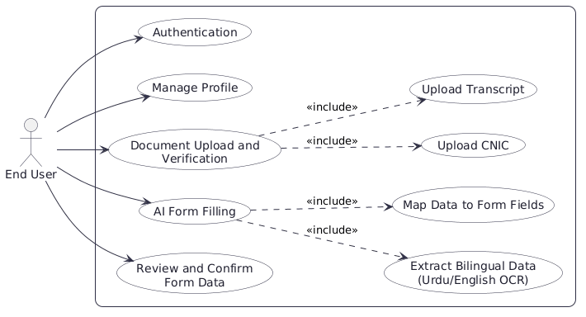
Figure 3. 1: Use Case Diagram for End User

Use Case Diagram for Text Extraction Using OCR
The Document Processing and OCR Module is one of the most important parts of AsaanForm because it handles the conversion of uploaded documents into machine-readable text. This module is responsible for accepting CNICs and transcripts, preprocessing the images for better recognition, extracting Urdu and English text separately through OCR, merging the extracted content, and sending it forward for AI-based field mapping. It also allows the user to review the OCR output and correct any mistakes before the data is used in form filling.
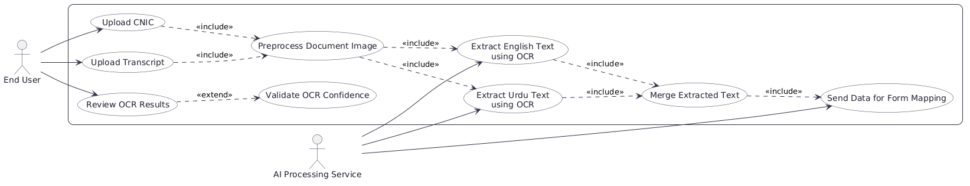
Figure 3. 2: Use Case Diagram for Text Extraction

Use Case Diagram for Track Processing Status
The Track Processing Status Module allows users to monitor the real-time progress of their document uploads, OCR extraction, AI form mapping, and overall submission workflow. This module is critical for user experience because it provides transparency into what the system is doing with their documents. Users can view the current stage of processing (uploading, validating, extracting text, mapping to form, ready for review), see processing completion percentage, receive notifications when tasks finish or fail, view error messages if something goes wrong, and access a history of all previously processed documents and their statuses. The system logs all processing steps and timestamps so users can understand the time taken for each stage and troubleshoot any issue.

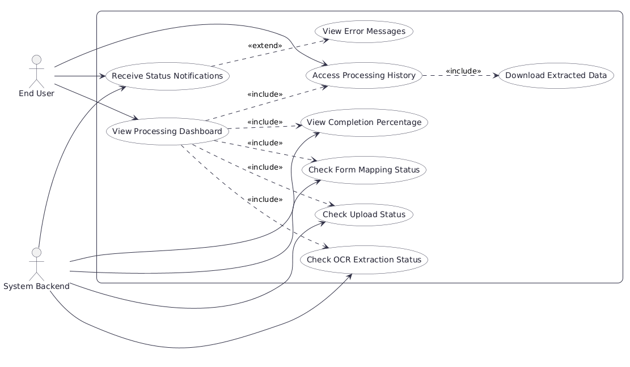
Figure 3. 3: Use Case Diagram for Track Processing Status

Detailed Use Case
The system includes several important use cases that define how different users interact with AsaanForm. For example, when a user uploads a CNIC, the system extracts Urdu and English text through OCR and prepares structured data for form mapping. When a user uploads an academic transcript, the system similarly processes it and requests user confirmation before mapping extracted information to form fields. Another major use case is document verification, where users can review extracted data, correct any OCR mistakes, and confirm accuracy before final form submission. Administrative use cases focus on form template management, user oversight, and processing analytics. These use cases formed the basis of the functional decomposition used throughout the design and implementation stages.
Table 3.1 Register User
Use Case ID: | UC-1
Use Case Name: | Register User
Actors: | Primary Actor: End User
Description: | The user registers a new account in the system by providing email, password, and basic personal information.
Trigger: | User selects the registration option from login page.
Preconditions: | PRE-1. Email is not already registered.  PRE-2. Password meets security requirements.
Postconditions: | POST-1 User account created in database.  POST-2.Move to login page.
Normal Flow: | - User enters Email and Password.  - System validates input.  - System create user profile.  - System confirms registration.
Alternative Flows: | 1.1 If email already registered, prompt user to login.
Exceptions: | 1.0.E1 Invalid Email format, system alerts and requests correction.
Business Rules: | BR-1 Passwords must be at least 6 characters.  BR-2 Email must be unique per user.
Assumptions: | Assume user has valid email address..
Table 3.2 Upload Document
Use Case ID: | UC-2
Use Case Name: | Upload Document
Actors: | Primary Actor: End User
Description: | User uploads identity documents (CNIC) or academic transcript in support image format for processing.
Trigger: | User selects upload documents option from dashboard.
Preconditions: | PRE-1. User is logged in.  PRE-2. File format is support (PDF, JPG, PNG).  PRE-3. File size is within limit.
Postconditions: | POST-1. Document stored in secure storage.  POST-2. Processing initiated automatically.
Normal Flow: | - User selects document file.  - System validates file format and size.  - System uploads and stores documents.  - System trigger OCR extraction.
Alternative Flows: | 2.1 If file too large, system requests compressions.
Exceptions: | - E1 Unsupported format, system shows error message.  1.0.E2 Upload fails, system retires or requests re-uploads.
Business Rules | BR-1 Only CNIC and transcripts format accepted.  BR-2 Documents encrypted during storage.
Assumptions: | Assume user provider clear, legible document images.
Table 3.3 Extract Bilingual Text
Use Case ID: | UC-3
Use Case Name: | Extract Bilingual Text
Actors: | Primary Actor: AI Processing Service  Secondary Actor: User
Description: | System applies OCR to extract Urdu and English text from uploaded documents through parallel processing pipelines..
Trigger: | Document upload completed successfully.
Preconditions: | PRE-1. Document stored in system.  PRE-2. OCR models initialized and ready.
Postconditions: | POST-1. Extracted text stored with confidence scores.  POST-2. User notified of extraction completion.
Normal Flow: | - System preprocesses document image.  - System runs English OCR pipeline.  - System runs Urdu OCR pipeline.  - System merges extracted text.  - System assigns confidence scores.
Alternative Flows: | 3.1 If Urdu text unclear, system flags for manual review.
Exceptions: | 1.0. E1 Image too blurry, system requests re-upload.  1.0. E2 OCR timeout, system retries with reduced resolution.
Business Rules | BR-1 Confidence scores below 70% flagged for user review.  BR-2 Extracted data must not be shared with third parties.
Assumptions: | Assume YOLO model successfully detects document regions..
Table 3.4:Map Data to Form Fields
Use Case ID: | UC-4
Use Case Name: | Map Data to Form Fields
Actors: | Primary Actor: AI Processing Service  Secondary Actor: User
Description: | System uses LLM-based reasoning to intelligently map extracted document data to appropriate form fields with field-level mapping confidence.
Trigger: | OCR extraction completed and user initiates form mapping
Preconditions: | PRE-1. Extracted text available in system.  PRE-2. Form template loaded and structure known.
Postconditions: | POST-1. Form fields populated with mapped data.  POST-2. Mapping confidence scores assigned to each field.
Normal Flow: | - System receives extracted document data.  - System analyzes form template structure.  - System applies LLM agent for semantic mapping.  - System populates form fields.
Alternative Flows: | 3.1 If confidence low, system presents options to user.
Exceptions: | 1.0.E1 Required field cannot be mapped, system alerts user.
Business Rules | BR-1 Mapping must respect data type constraints per field.  BR-2 User always has final review before submission.
Assumptions: | Assume form template properly defines all required fields.
Table 3.5: Review and Correct Extracted Data
Use Case ID: | UC-5
Use Case Name: | Review and Correct Extracted Data
Actors: | Primary Actor: End User
Description: | User reviews OCR-extracted text and form mappings.
Trigger: | Extraction and mapping completed; user notified to review.
Preconditions: | PRE-1. User is logged in.  PRE-2. Extracted data and mappings available.
Postconditions: | POST-1. Corrections saved to system.  POST-2. Updated data ready for form submission.
Normal Flow: | - User views extracted data with confidence scores.  - User reviews form field mappings.  - User edits fields as needed.  - User confirms corrections
Alternative Flows: | 3.1 User requests re-extraction if quality poor.
Exceptions: | 1.0. E1 User timeout, changes discarded with warning.  1.0. E2 Field validation fails, system shows error.
Business Rules | BR-1 All manual edits logged with timestamp for audit.
Assumptions: | Assume user carefully reviews all extracted data.
Table 3.6: Preview Auto-Filled Form
Use Case ID: | UC-6
Use Case Name: | Preview Auto-Filled Form
Actors: | Primary Actor: End User
Description: | User views complete form with all auto-filled fields before final submission to verify layout, values, and completeness.
Trigger: | User selects preview form option after corrections complete.
Preconditions: | PRE-1. All required fields populated or marked optional.  PRE-2. Validation checks passed.
Postconditions: | POST-1. Form preview displayed in read-only format.
Normal Flow: | - System generates form preview.  - System displays form layout with all filled values.  - User reviews form content.  - User confirms readiness or requests changes.
Alternative Flows: | 3.1 User requests more changes, returns to review stage.
Exceptions: | 1.0.E1 Form generation error, system shows error messages.
Business Rules | BR-1 Preview is read-only; user cannot edit here.
Assumptions: | Assume form template renders correctly in preview mode.
Table 3.7: Use AI Chatbot
Use Case ID: | UC-7
Use Case Name: | Use AI Chatbot
Actors: | Primary Actor: End User
Description: | User queries about the AI chatbot linked to their database for AsaanForm questions.
Trigger: | User opens chatbot interface.
Preconditions: | PRE-1. User is logged in.
Postconditions: | POST-1. Response provided based on database.
Normal Flow: | - User input query.  - System processes with AI.  - System responds.
Alternative Flows: | None.
Exceptions: | 1.0.E1 Query unclear, ask for clarification.
Business Rules | BR-1 Responses personalized.
Assumptions: | AI models are integrated properly.
Table 3.8: Download Completed Form
Use Case ID: | UC-8
Use Case Name: | Download Completed Form
Actors: | Primary Actor: End User
Description: | User downloads a copy of the completed and submitted form in PDF format for personal records or institution requirements.
Trigger: | User selects download option from submission history.
Preconditions: | PRE-1 User is logged in.  PRE-2. Form has been successfully submitted.
Postconditions: | POST-1. PDF file generated and downloaded to user device.
Normal Flow: | - User clicked the download button.  - System generates PDF with all filled data.  - System initiates download to user device.
Alternative Flows: | None.
Exceptions: | 1.0.E1 PDF generation fails, system shows error message.
Business Rules | BR-1 Downloaded PDF contains receipt confirmation.  BR-2 PDF generation respects data privacy.
Assumptions: | Assume user has sufficient device storage.
Table 3.9: View Submission History
Use Case ID: | UC-9
Use Case Name: | View Submission History
Actors: | Primary Actor: End User
Description: | User views chronological history of all submitted forms.
Trigger: | User selects submission history from dashboard.
Preconditions: | PRE-1. User is logged in.  PRE-2. User has at least one prior submission.
Postconditions: | POST-1. History displayed below the user profile.
Normal Flow: | - User opens submission history.  - System retrieves all user submissions.  - System displays reports.
Alternative Flows: | None.
Exceptions: | 1.0.E1 No submissions found, system shows empty state.
Business Rules | BR-1 Users see only their own submissions.  BR-2 History retained for audit purposes.
Assumptions: | Assume user has stable internet for history retrieval.

Functional Requirements
The functional requirements of AsaanForm define the core capabilities the system must deliver. Key requirements include user account registration and secure authentication, document upload and preprocessing for CNICs and academic transcripts, bilingual OCR extraction of both Urdu and English text, object detection for document region localization, AI agent-based intelligent field mapping, form creation and management, automated form filling with user review and correction, and session-based document and form data management. All functional requirements identified in the SRS were successfully implemented and mapped to design artifacts.
Table 3.10: User Registration and Authentication
Identifier | FR-1
Title | User Registration and Authentication
Requirement | The system shall allow users to registers using their credentials and authenticate securely before accessing any document or form functionality.
Source | User requirements
Rationale | To ensure that document data and form submissions are accessible only authorized users.
Business Rule | BR-1: Email must be unique per account.
Dependencies | None.
Priority | High

The system shall allow users to register an account and authenticate securely before interacting with any part of the application. This requirement is foundational because the entire workflow of AsaanForm depends on maintaining a controlled and identifiable user session. Without authenticated access, sensitive document content such as CNIC information and academic records would be exposed without accountability.
From a project perspective, this requirement provides the entry point for all other user-facing functionality. A registered user is able to upload documents, manage forms, and receive AI-assisted completions, all of which are tied to their account context. The business rule requiring a unique email per account ensures that user identities remain distinct and traceable throughout the system.
Table 3.11: Document Upload and Preprocessing
Identifier | FR-2
Title | Document Upload and Preprocessing
Requirement | The system shall allow users to upload identity documents and academic transcripts, and the backend shall preprocess uploaded images for sub sequent OCR and detection tasks.
Source | User requirements
Rationale | To provide the raw input material that the AI pipeline depends on for extraction.
Business Rule | BR-1: Supported file types restricted to image and PDF formats.
Dependencies | FR-1
Priority | High
The system shall allow authenticated users to upload scanned or photographed copies of their documents, including CNICs and academic transcripts, and the backend shall apply necessary preprocessing steps to prepare these images for downstream analysis. This requirement is critical because the quality of all subsequent extraction and mapping operations depends directly on the state of the input image entering the pipeline.
Preprocessing steps such as noise reduction, contrast enhancement, and orientation correction ensure that the OCR and detection stages receive inputs in a condition suitable for reliable operation. The restriction to image and PDF formats under the associated business rule keeps the pipeline predictable and avoids handling unsupported or malformed file types that could disrupt processing.
Table 3.12: Object Detection and Region Localization
Identifier | FR-3
Title | Object Detection and Region Localization
Requirement | The system shall apply a YOLO-based object detection model to identify and localize distinct region within uploaded documents before passing them to the OCR stage.
Source | AI integration requirements
Rationale | To improve extraction accuracy by isolating semantically meaningful regions rather than applying OCR to entire document images.
Business Rule | BR-1: Detection must precede OCR in the processing pipeline.
Dependencies | FR-2.
Priority | High
The system shall apply YOLO-based object detection [9] to each uploaded document image to identify and localize discrete regions such as name fields, date fields, identification numbers, and other structured areas before any text extraction takes place. This requirement exists because applying OCR blindly to an entire document image produces noise and misaligned text extraction, whereas isolating regions first allows each area to be processed with greater precision and in its correct semantic context.
In the broader project design, this requirement represents the first major AI stage of the document processing pipeline and directly conditions the quality of all downstream outputs. The business rule mandating that detection must precede OCR reflects the architectural dependency that makes this stage non-negotiable for maintaining system accuracy.
Table 3.13: Bilingual OCR Extraction
Identifier | FR-4
Title | Bilingual OCR Extraction
Requirement | The system shall extract text from localized document regions in both Urdu and English, handling the bilingual nature of Pakistani identity and academic documents.
Source | AI integration requirements
Rationale | To ensure complete and accurate extraction from documents that contain a mixture of Urdu and English content.
Business Rule | BR-1: Both scripts must be processed within a single extraction pass.
Dependencies | FR-3
Priority | High
The system shall perform optical character recognition on localized document regions and extract text in both Urdu and English scripts within a unified extraction process. This requirement is among the most technically significant in the project because Pakistani documents such as CNICs and academic transcripts routinely present both languages simultaneously, and a system that handles only one script would produce incomplete or misleading extraction results.
The requirement reflects the core bilingual challenge that AsaanForm is built to address. By supporting both scripts in a single pass, the system avoids the need for separate language-specific pipelines and reduces processing complexity. The associated business rule reinforces that both scripts are treated as equally mandatory outputs rather than optional enhancements.
Table 3.14: AI Agent-Based Field Mapping
Identifier | FR-5
Title | AI Agent-Based Field Mapping
Requirement | The system shall use an LLM-based agent, orchestrated through LangChain, to reason over extracted text and intelligently map it to the correct fields of the target digital form.
Source | AI integration requirements
Rationale | To automate the connection between unstructured extracted content and structured form fields without requiring manual user intervention.
Business Rule | BR-1: Mapping decisions must be explainable and reviewable by the user.
Dependencies | FR-4
Priority | High
The system shall employ an LLM-based agentic component, managed through LangChain [3] orchestration, to receive extracted text from the OCR stage and reason over it to determine which pieces of information correspond to which fields in the target form. This requirement is central to the value proposition of AsaanForm because it replaces the manual and error-prone task of interpreting and re-entering document content with an intelligent automated mapping process.
The agent must handle ambiguity, infer appropriate mappings when field labels and extracted content do not match literally, and produce a structured output that the frontend can present to the user for review. The business rule requiring that mapping decisions remain reviewable ensures that the system does not silently override user intent, preserving transparency and user control over the final form submission.
Table 3.15: Form Creation and Management
Identifier | FR-6
Title | Form Creation and Management
Requirement | The system shall allow users to create, save, and manage digital forms with customizable fields that serve as the target structure for AI-assisted completion.
Source | User requirements
Rationale | To provide the structured target that the AI mapping agent works against when filling information from documents.
Business Rule | None.
Dependencies | FR-1
Priority | Medium
The system shall allow authenticated users to create digital forms with customizable fields and save them for repeated use across different document upload sessions. This requirement is necessary because the AI mapping agent must have a well-defined target structure to work against, and users may need to fill different types of forms across different institutional or governmental contexts.
By enabling form creation and management, AsaanForm becomes adaptable to a wide range of use cases rather than being limited to a fixed set of pre-defined templates. Users dealing with government forms, university applications, or institutional registrations can define their specific field structures and reuse them without reconfiguration, which adds significant practical efficiency to the platform..
Table 3.16: Automated Form Filling with User Review
Identifier | FR-7
Title | Automated Form Filling with User Review
Requirement | The system shall populate form fields automatically using AI agent output and present the completed form to the user for review and manual correction before final submission.
Source | User requirements
Rationale | To combine the efficiency of automated completion with the accuracy assurance of human oversight.
Business Rule | BR-1: No form shall be submitted without user confirmation.
Dependencies | FR-5, FR-6
Priority | High

The system shall automatically populate the fields of a user-selected form using the output produced by the AI mapping agent and then display the pre-filled form to the user so that they may review, adjust, and confirm all entries before the form is considered complete. This requirement balances the automation objective of the project against the practical reality that AI-assisted mapping may occasionally produce imperfect results, particularly in edge cases involving unusual document formatting or degraded image quality.
The business rule that no form shall be submitted without user confirmation ensures that AsaanForm supports rather than replaces human judgment. This is especially important in contexts such as government or academic form submission where errors carry formal consequences for the user.
Table 3.17: Multi-Document Session Support
Identifier | FR-8
Title | Multi-Document Session Support
Requirement | The system shall support uploading and processing multiple documents within a single session, aggregating extracted information for use in a single form completion task.
Source | User requirements
Rationale | To allow users who require information from more than one document to complete a single form without initiating separate sessions.
Business Rule | None
Dependencies | FR-3,FR-5
Priority | Medium

The system shall allow users to upload and process more than one document within the same session, with extracted content from each document being aggregated and made available to the AI agent during the field mapping stage. This requirement reflects a realistic usage scenario in which a single form may demand information that spans multiple source documents, such as a registration form requiring both CNIC details and academic transcript data simultaneously.
Without this capability, users would be forced to complete partial forms manually or manage separate sessions and merge results themselves, which reintroduces exactly the kind of manual effort that AsaanForm is designed to eliminate. Supporting multi-document sessions therefore directly strengthens the core value the system provides.

Non-Functional Requirements
The non-functional requirements ensure that AsaanForm is usable, secure, scalable, reliable, and maintainable. The system must provide a clear and accessible interface for all users so that document upload, form selection, and AI-assisted completion can be carried out efficiently without technical expertise. The web application must also perform reliably with fast response times across both the AI processing backend and the web-facing frontend.
Security is a significant non-functional concern because the platform handles personally identifiable information extracted from government identity documents and academic records. Therefore, the system must use encrypted communication, authenticated sessions, role-aware access control, and secure data handling practices. The system should also be scalable enough to accommodate growing numbers of users and document processing requests while remaining stable and maintainable over time.

Usability
The system must be easy to learn and efficient to use for Pakistani citizens, students, and professionals who may have varying levels of technical familiarity. According to the SRS, users should be able to upload a document, select a target form, and receive an AI-completed draft without requiring prior training or technical guidance. New users should be able to complete registration and initiate their first form-filling session within a minimal number of steps.
In AsaanForm, usability is especially important because the target audience includes individuals who interact with government and institutional forms under time pressure. The system therefore uses a clean, step-driven interface that guides users through document upload, AI processing, field review, and form submission in a structured sequence that minimises cognitive overhead and reduces the likelihood of user error.
Table 3.18: Usability
Identifier | NFR-1
Title | Usability
Requirement | Users should be able to upload documents and complete AI-assisted form filling through intuitive workflows with minimal training.
Importance | High usability is essential for adoption across a diverse and non-technical user base.
Project Interpretation | AsaanForm uses a step-driven interface, structured navigation, and clear feedback at each stage of the pipeline.

Performance
The system must perform efficiently under normal operating conditions. The SRS specifies that page loads should complete within acceptable time limits on standard broadband connections, AI document processing for standard image inputs should return results within a reasonable window, and the platform should remain responsive when multiple users are active simultaneously. Given that the AI pipeline involves object detection, OCR, and LLM inference, processing time expectations were set realistically while still reflecting the user's need for a timely response.
These performance expectations shaped architectural decisions in AsaanForm, including the separation of the AI backend from the web backend, the use of Groq API for fast LLM inference, and asynchronous processing design where possible. Performance is particularly important because a system that introduces delays longer than manual form filling would fail to deliver its core value proposition.
Table 3.19: Performance
Identifier | NFR-2
Title | Performance
Requirement | Timely page loading, responsive AI document processing, and acceptable concurrent user handling.
Importance | Essential for user confidence and for delivering meaningful efficiency gains over manual form completion.
Project Interpretation | Separated AI and web backends, fast LLM inference via Groq, and asynchronous pipeline design support responsiveness.

Security
The system must protect personally identifiable information extracted from CNICs and academic transcripts through secure communication and controlled access. The SRS requires HTTPS encryption for all data in transit, secure session-based authentication to control user access, and secure storage practices for extracted document data. These expectations are especially important given that the documents processed by AsaanForm contain sensitive national identity information.
In AsaanForm, security is integrated into the system's structure rather than treated as an optional layer. Authentication governs access to all document and form operations, communication between the frontend and both backends uses encrypted channels, and extracted document data is handled with awareness of its sensitivity. Since user trust depends heavily on the system's ability to protect private information, security remains one of the most important non-functional dimensions of the project.
Table 3.20: Security
Identifier | NFR-3
Title | Security
Requirement | The system shall protect user data through encryption, secure authentication, and controlled access to document content.
Importance | Critical due to the sensitive nature of identity and academic document information.
Project Interpretation | HTTPS communication, session-based authentication, and secure backend design support this requirement.

Scalability
The system must support growth from a modest initial user base to a larger deployment without significant degradation in processing or responsiveness. The SRS states that AsaanForm should accommodate an increasing number of concurrent document sessions and form-filling requests, with the architecture supporting independent scaling of the AI processing backend and the web backend as demand grows.
In project terms, scalability influenced the decision to maintain two separate backend services rather than a single monolithic server. The FastAPI-based AI backend and the Node.js web backend can be scaled independently depending on which component experiences higher load. This separation ensures that increased demand on the document processing pipeline does not degrade the responsiveness of general web operations, and vice versa.
Table 3.21: Scalability
Identifier | NFR-4
Title | Scalability
Requirement | The platform shall support independent scaling of AI processing and web service components.
Importance | Necessary for handling growing user demand across document-heavy workflows.
Project Interpretation | Dual-backend architecture with separated AI and web services supports component-level scaling.

Reliability
The system must remain dependable during routine use, particularly during the AI processing stages where failures could leave users with incomplete form outputs. The SRS specifies that the system should handle AI pipeline failures gracefully, preserving the ability for users to review partially completed forms and make manual corrections rather than encountering unrecoverable errors. The user review stage built into the automated form filling workflow directly supports this expectation.
Reliability in AsaanForm is reflected in the mandatory user review step before any form is considered complete, the fallback ability to manually correct any field where AI mapping produces an uncertain or incorrect result, and the separation of pipeline stages so that a failure in one stage does not cascade unpredictably through the rest of the system. This ensures that automation never becomes a single point of failure for the user's form completion task.
Table 3.22: Reliability
Identifier | NFR-5
Title | Reliability
Requirement | The system shall handle AI processing failures gracefully and preserve user ability to review and correct all outputs.
Importance | Required for user trust and practical dependability during form completion workflows.
Project Interpretation | Mandatory review stage and modular pipeline design support graceful failure handling and system resilience.

Maintainability
The system must be easy to update, extend, and test over time. The SRS requires a modular codebase structure in which the AI pipeline, web backend, and frontend can be developed, tested, and updated independently. This is particularly important for AsaanForm because both the AI components and the supported document types may evolve as the system is extended to handle additional document formats or new form structures.
The project's architecture directly supports this requirement. The AI backend, web backend, and React frontend are maintained as separate layers with well-defined communication interfaces between them. This separation makes it straightforward to replace or upgrade individual components, such as substituting a different LLM provider or adding support for new document types, without requiring changes across the entire codebase.
Table 3.23: Maintainability
Identifier | NFR-6
Title | Maintainability
Requirement | The codebase shall remain modular, documented, and structured for independent component updates and testing.
Importance | Important for long-term enhancement as document types, AI models, and form requirements evolve.
Project Interpretation | Separated frontend, AI backend, and web backend layers with defined interfaces support maintainability.

Browser Compatibility
The platform must remain accessible through modern web browsers including Google Chrome, Mozilla Firefox, Microsoft Edge, and Safari. Since AsaanForm is delivered entirely as a web application, browser compatibility is necessary to ensure that users across different devices and operating systems can access the system without any specialized software installation.
The use of React.js and standard web technologies helps satisfy this requirement by targeting browser-rendered responsive interfaces that behave consistently across platforms. This is especially relevant for the Pakistani user base, where device and browser diversity can be considerable, and where requiring a specific software environment would present an unnecessary adoption barrier.
Table 3.24: Browser Compatibility
Identifier | NFR-7
Title | Browser Compatibility
Requirement | The system shall operate correctly across modern web browsers on both desktop and mobile devices.
Importance | Necessary for broad accessibility across the diverse device landscape of the target user population.
Project Interpretation | React.js-based responsive frontend supports consistent cross-browser operation.

Communication Interfaces
The platform must support secure and structured communication between its components through well-defined APIs. The SRS explains that the React frontend must communicate with both the FastAPI AI backend and the Node.js web backend through RESTful API interfaces, with all communication occurring over HTTPS. These interfaces must handle document uploads, processing requests, extracted data transfer, and form management operations reliably and securely.
This requirement is relevant because AsaanForm depends on multiple communication paths rather than a single internal workflow. The AI processing pipeline exchanges structured data between detection, extraction, and agent stages, while the frontend consumes results from both backends to assemble the user-facing form completion experience. A failure or inconsistency in any of these communication paths would directly affect the integrity of the system's output.
Table 3.25: Communication Interfaces
Identifier | NFR-8
Title | Communication Interfaces
Requirement | The system shall support secure RESTful API communication between the frontend and both backend services.
Importance | Supports integrated system behavior across the AI pipeline and web service layers.
Project Interpretation | REST APIs over HTTPS between React frontend, FastAPI AI backend, and Node.js web backend support this requirement.

Chapter 4

Design and Architecture

Design and Architecture
The design and architecture of AsaanForm were developed to satisfy the functional and non-functional requirements identified during requirement analysis while keeping the system modular, secure, and straightforward to extend. Since the platform is intended to handle sensitive personal identity and academic documents on behalf of Pakistani users, the architecture needed to support both reliable document processing and intelligent form completion without introducing unnecessary complexity or making the system difficult to maintain over time. For that reason, the approved SDD presents AsaanForm as a multi-tier application in which the user interface, web application logic, AI processing pipeline, and data storage are separated into distinct layers that communicate through well-defined interfaces. This separation of concerns is important because AsaanForm combines several technically distinct responsibilities within a single user-facing workflow. Document upload, object detection, bilingual OCR, LLM-based agentic reasoning, form management, and user authentication are all part of the system, yet each belongs to a different technical domain. By isolating these responsibilities into separate tiers and services, AsaanForm can support independent development and scaling of each component without requiring changes across the entire system. This also reduces coupling between layers, improves the readability of the overall design, and makes future enhancements such as support for additional document types, alternative LLM providers, or new form templates much easier to introduce. The architecture also reflects the dual-backend nature of the project itself. AsaanForm separates its AI processing concerns from its general web application concerns by maintaining a dedicated FastAPI-based AI backend alongside a Node.js web backend, both of which serve a shared React frontend. This division was a deliberate architectural decision driven by the recognition that the AI pipeline, involving YOLO-based detection, OCR, LangChain orchestration, and Groq API inference, carries different performance, dependency, and scaling characteristics than the web application layer responsible for user management, form storage, and session handling. By keeping these two backends independent, the system avoids the fragility that would result from mixing AI processing logic with general application logic in a single service.

System Architecture
AsaanForm follows a clean multi-tier client-server architecture. The client tier consists of a React.js [4] dashboard designed for end users and administrators. This interface is responsible for user interaction, form input validation at the interface level, document upload handling, and presentation of extracted fields, form previews, submission history, and processing status. The web application tier, developed with Node.js [7], manages business logic, authentication, authorization, session handling, workflow coordination, and RESTful APIs.
The AI processing tier, implemented through Python FastAPI services [1], performs document preprocessing, YOLO-based object detection [9], bilingual OCR for Urdu and English text, and LLM-based field mapping through LangChain [3] with Groq inference. The data tier stores user profiles, forms, extracted records, and related metadata required for processing and retrieval. The external services tier supports integration with Groq API for language model inference and notification channels such as email for user updates. This architecture ensures that AsaanForm remains maintainable, secure, and scalable as additional form templates and intelligent processing features are introduce.

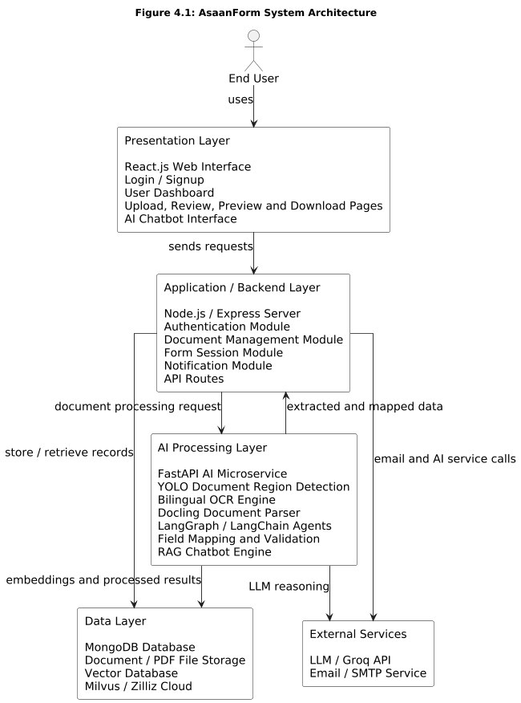

Figure 4. 1: System Architecture for AsaanForm

Data Representation
In AsaanForm, data is stored using a hybrid storage design that supports the efficient management of user accounts, uploaded documents, extracted text content, form structures, AI agent outputs, and session state. The system combines structured and unstructured storage approaches to reflect the dual nature of its data, where user and form records benefit from structured relational organization while extracted document content and AI-generated outputs are better suited to flexible document-oriented storage. This hybrid representation ensures that all major modules of the system, including user management, document processing, OCR extraction, agentic field mapping, and form completion, can store, retrieve, and update information accurately and consistently across both the web backend and the AI processing backend.
The central data entity in AsaanForm is the User structure, which stores common account information such as full name, email address, hashed password, account creation timestamp, and authentication token details. This entity serves as the entry point for all user-facing operations in the system and governs access to document upload, form management, and AI-assisted completion workflows. Authentication and session management are built directly on top of this structure, ensuring that all document and form data remains associated with a verified and identifiable account throughout its lifecycle in the system.
The Document module stores metadata and processing state information for every file uploaded by a user. Each document record holds the user identifier, original file name, upload timestamp, document type such as CNIC or academic transcript, file storage path, and current processing state indicating whether the document is pending, under analysis, or fully processed. This representation allows the system to track each uploaded document through the entire pipeline from initial upload to final extraction output, and it supports the session-level aggregation of multiple documents that may be combined to fill a single form.
The Extraction Results module stores the output produced by the bilingual OCR and object detection stages of the AI pipeline. Each extraction record is linked to its parent document and contains the detected region labels, the raw text extracted from each region in either Urdu or English, confidence indicators, and the timestamp of processing. This structured storage of extracted content allows the LangChain-based agent [3] to consume well-organized inputs during the field mapping stage rather than working against raw and unlabelled text, which directly improves the reliability and traceability of the mapping decisions the agent produces.
The Form module is a core structural component of the data representation because it defines the target against which all AI-assisted mapping operates. Each form record stores the user identifier of its creator, a form title, a creation timestamp, and an ordered collection of field definitions. Each field definition holds a field label, expected data type, and an optional description that assists the agent in understanding what kind of extracted content should be mapped to that field. This design makes form structures reusable across multiple document sessions and allows users to build a personal library of form templates suited to their specific institutional or governmental contexts.
The Form Completion module stores the output of the AI agent's field mapping process for a given session. Each completion record links a specific form to a specific set of processed documents and holds the agent-generated field values alongside a review status indicating whether the user has confirmed, corrected, or rejected individual mappings. This structure preserves the distinction between AI-generated suggestions and user-confirmed values, ensuring that the final submitted state of any form reflects deliberate human review rather than unverified automated output.
The data representation also supports the pipeline coordination that connects the AI backend with the web backend. When a user uploads a document, the web backend creates a document record and forwards the file to the FastAPI AI backend for processing. The AI backend performs detection and OCR, stores extraction results against the document identifier, and runs the LangChain agent to produce a field mapping output that is then written back into the form completion record accessible by the web backend. This coordinated data movement across both backends is made possible by shared document and form identifiers that serve as consistent reference keys throughout the entire processing workflow.
To ensure performance and consistency, the system applies indexing on frequently queried attributes such as user identifiers, document identifiers, form identifiers, and processing state fields. These indexes support fast retrieval during active user sessions where multiple documents and form completions may be queried simultaneously. Foreign key relationships and clearly defined associations between users, documents, extraction results, forms, and completions reduce redundancy and maintain referential integrity across all modules.
The data representation also supports the security requirements of the system. Document file paths are stored without exposing raw filesystem structure to the frontend, extracted content containing sensitive personal information is accessible only within authenticated sessions, and the separation between AI backend storage and web backend storage ensures that raw document processing artifacts are not directly exposed through the user-facing API. Timestamps, processing states, and review status fields further provide an audit-friendly record of how each piece of document data moved through the system and what decisions were made at each stage.
Overall, the data representation in AsaanForm does not merely serve as a passive storage mechanism; it acts as the coordination layer that binds the document processing pipeline, the agentic field mapping workflow, and the user-facing form management experience into a coherent and traceable system. Through its hybrid and role-aware design, the database supports the smooth functioning of AsaanForm as a modern AI-powered form completion platform capable of handling bilingual Pakistani documents accurately and efficiently.
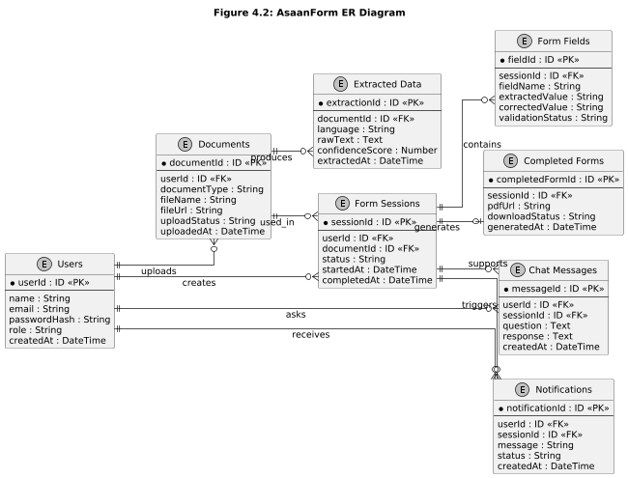
Figure 4. 2: Data Representation Diagram of AsaanForm

Process Flow
The process flow representation of AsaanForm illustrates how the main users and system components interact in a structured sequence. It provides a clear view of how authenticated users, the web application backend, and the AI processing backend work together to extract information from uploaded documents and intelligently populate digital forms in a controlled and reviewable manner.
In the Document Upload and Processing workflow, the process begins when a registered user logs into the system and navigates to the document upload interface. The user selects one or more documents, such as a CNIC or academic transcript, and submits them through the React frontend. The web backend receives the upload, creates a document record, and forwards the file to the FastAPI AI backend for processing. The AI backend first applies the YOLO object detection model to localize distinct regions within the document image, then passes each detected region through the bilingual OCR engine to extract text in Urdu, English, or both as required. The extracted content is stored against the document record and made available for the subsequent mapping stage.
In the Agentic Field Mapping workflow, once extraction is complete the user selects a target form from their saved form library or creates a new one. The LangChain-based agent receives the structured extraction results alongside the form field definitions and reasons over the content to determine the most appropriate mapping between extracted values and form fields. The agent produces a complete set of field mappings which are written into a form completion record and returned to the frontend as a pre-filled draft form. This stage transforms the raw extracted content into a structured and user-ready output without requiring any manual re-entry from the user.
In the Review and Confirmation workflow, the pre-filled form is presented to the user for review. The user examines each field, corrects any mapping that the agent produced incorrectly, and confirms the final values before marking the form as complete. No form completion is recorded as finalized without explicit user confirmation, ensuring that the automation provided by the AI pipeline always remains subject to human oversight. Once confirmed, the completed form data is stored in the system and the user may export or submit it as required by their institutional context.
Overall, the process flow shows that AsaanForm is designed to automate the most repetitive and error-prone aspects of form filling, namely document reading, text extraction, and field mapping, while preserving deliberate human control at the final review and confirmation stage where accuracy carries the most consequence for the user
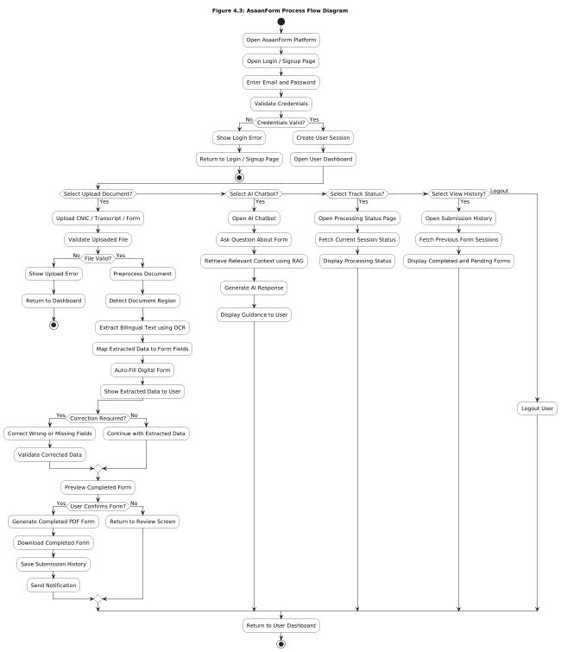
Figure 4. 3: Process Flow Representation of AsaanForm

Design Models
The design models of AsaanForm present the static and dynamic structure of the system using UML diagrams. Since AsaanForm is a pipeline-driven, AI-integrated web application built around document processing and intelligent form completion, the most appropriate design artifacts are the Class Diagram and Sequence Diagrams for the three primary workflows: Document Upload and Processing, Agentic Field Mapping, and Form Review and Confirmation. These diagrams explain how the system is structured internally and how the major workflows are executed across the frontend, web backend, AI backend, and data storage layers.
The class diagram captures the static architecture of the system, including associations, dependencies, and relationships among the main entities such as User, Document, ExtractionResult, Form, FieldDefinition, and FormCompletion. The sequence diagrams show the time-based interaction between the authenticated user, the React frontend, the Node.js web backend, the FastAPI AI backend, the LangChain agent, and the database. Together, these diagrams provide a complete view of how AsaanForm operates from both structural and behavioral perspectives, covering the full journey from initial document upload through bilingual extraction and agentic mapping to final user-confirmed form completion.

Class Diagram
The class diagram of AsaanForm represents the core structural design of the system and the relationships among its primary entities. At the center is the User class, which stores shared account information such as full name, email address, hashed password, and account creation timestamp. The User class is associated with both the Document and Form entities, reflecting the fact that a single authenticated user may upload multiple documents for processing and maintain multiple form templates for reuse across different sessions. This central association makes the User class the anchor point from which all major system workflows originate, whether they involve document processing, form management, or form completion.
The Document class is linked to the ExtractionResult class, which stores the output produced by the YOLO object detection and bilingual OCR stages of the AI pipeline. Each ExtractionResult holds the detected region label, extracted text content, identified language, and a confidence indicator associated with the extraction. The Form class contains a collection of FieldDefinition objects, each of which stores a field label, expected data type, and an optional descriptive hint used by the LangChain agent during mapping. The FormCompletion class connects a Form instance to one or more Document instances and stores the agent-generated field mappings alongside a review status that tracks whether the user has confirmed, corrected, or is still reviewing the pre-filled output. This class design is appropriate because it maps directly to the document processing and form completion domain that AsaanForm addresses, keeping processing entities, form structure entities, and completion state entities distinct while maintaining well-defined associations between them. The AI pipeline outputs are stored independently from the form completion records, ensuring that changes to the extraction or mapping logic do not require structural changes to the user or system
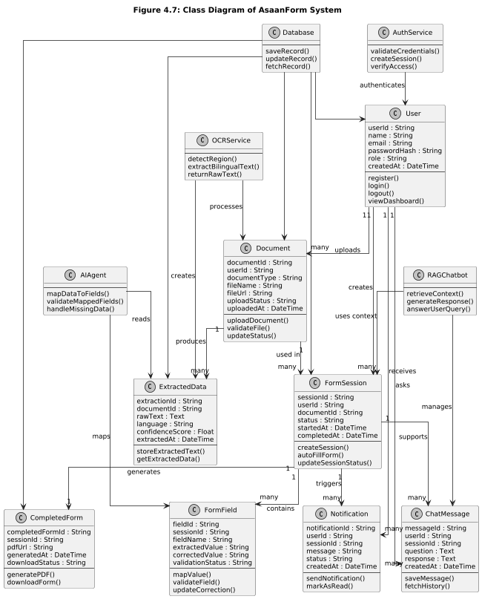
Figure 4. 4: Class Diagram of AsaanForm

Sequence Diagram for Document Upload
The document upload module defines the workflow for processing user-uploaded documents such as CNICs, certificates, and transcripts within the AsaanForm system. The process begins when a user selects and uploads a document through the frontend interface. The system securely receives and stores the document to preserve the original file for future reference. Once stored, the system initiates the document processing pipeline. If the uploaded file is in PDF format, it is converted into high-resolution images (300 DPI) to improve processing accuracy. The system then performs bilingual OCR (Optical Character Recognition) to extract text from both English and Urdu content.
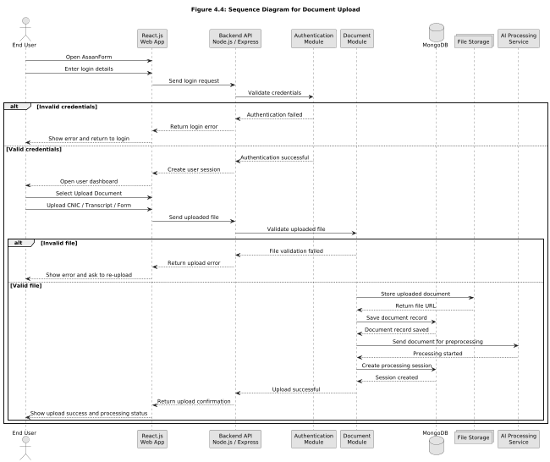
Figure 4. 5: Sequence Diagram of Document Upload
This sequence is important because it captures the most sensitive part of AsaanForm. The diagram therefore shows a balanced interaction between automation and text extraction oversight, which is a central design principle of the project.

Sequence Diagram for Chat(RAG)
The Chat Module in AsaanForm enables users to ask natural language questions about their uploaded documents and forms using a Retrieval Augmented Generation (RAG) approach powered by a vector database and advanced language models. The process begins when the user opens the chat interface from the frontend and enters a query.
When the user sends a message, the frontend forwards the query along with user context (such as user ID and optional form or document reference) to the AI backend. The AI backend converts the query into a vector embedding using the same embedding model used during document processing. It then performs a semantic search in the vector database to retrieve the most relevant document chunks associated with the user.
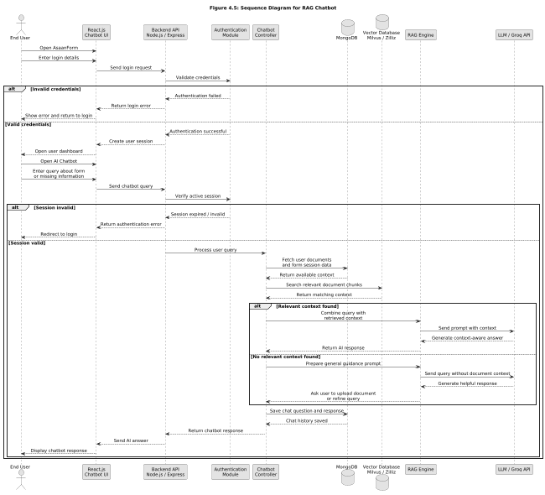
Figure 4. 6: Sequence Diagram of RAG System

Sequence Diagram for Form Filling
The Form Filling module in AsaanForm starts when the end user selects one previously uploaded document and one form template. After the user clicks Auto Fill, the Frontend sends the request to the AI Backend using the existing form-filling endpoint. The AI Backend then runs the available internal agents used in the system, the Mapping Agent matches extracted document values with form fields, the Validator Agent checks the values, and the Overlay Agent places the values onto the form at the correct coordinates.
After processing, the AI Backend returns the filled PDF and the mapping result to the Frontend. The Frontend shows the pre-filled form to the user for review, and the user can then confirm or download the final filled form.
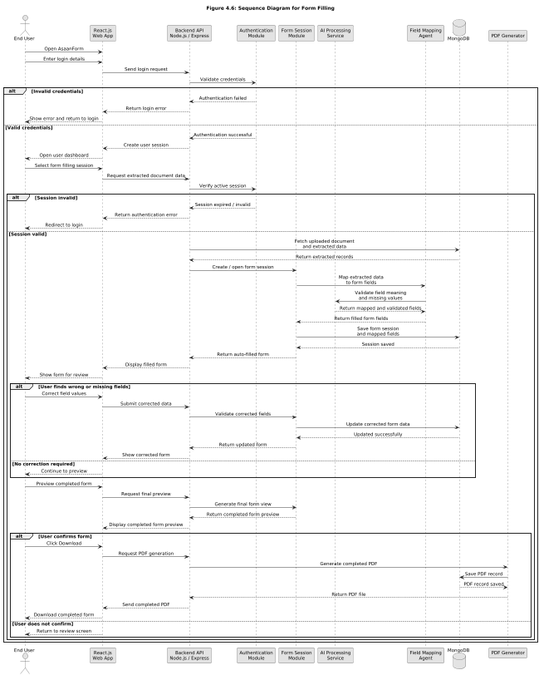
Figure 4. 7: Sequence Diagram of Form Filling

Chapter 5

Implementation

Implementation
The implementation of Medrotic translates the approved requirements and design models into a functioning software product. It combines frontend development, backend service creation, AI integration, database connectivity, and communication features into one coordinated system. The implementation follows the architecture described in the SDD and reflects the iterative development strategy selected during project planning. In practice, this means the system was built in modules so that each major feature could be developed, connected, and tested without affecting the entire application at once.
The implementation phase focuses on making the system usable in real workflows. Frontend screens were connected to backend endpoints, AI services were integrated for OCR and computer vision tasks, and database operations were tied and used throughout the platform.

Algorithm
Several core algorithms power the working of AsaanForm. The user authentication algorithm validates login credentials and controls access to the system based on the registered user profile. The document upload and processing algorithm handles personal documents such as CNIC, certificates, and transcripts by saving the file in the local storage directory, detecting the file type, and routing it through the appropriate OCR and extraction pipeline. If the uploaded file is a PDF, the system first converts it into images before performing bilingual OCR and structured data extraction.
The form mapping algorithm is responsible for connecting extracted document values with the corresponding fields in a selected form. During this step, the mapping agent matches source data with destination form fields, the validator agent checks whether the values satisfy field constraints, and the overlay agent places the data at the correct coordinates on the form template. The result is a pre-filled form that the user can review before final confirmation.
The chat algorithm supports retrieval-augmented generation. When the user asks a question, the query is transformed into embeddings and compared against stored vectors in Milvus. The system retrieves the most relevant document chunks, combines them with the user query, and generates a context-aware response. This allows the chatbot to answer questions based on the user’s own uploaded documents rather than generic model output.
The submission and record update algorithm ensures that confirmed documents and forms are saved in the database through the backend services. Once the user reviews extracted data or pre-filled forms and confirms them, the system updates the corresponding MongoDB records and preserves the workflow history. Validation, exception handling, and logging are also part of the implementation so that incomplete uploads, invalid file types, and processing failures can be detected early. Overall, these algorithms are not isolated theoretical steps; they are directly embedded in the AsaanForm workflow and determine how users upload documents, fill forms, and interact with the chatbot.

External APIs
AsaanForm depends on a small set of service interfaces that keep the platform modular and easy to maintain. The Node.js backend [7] is responsible for authentication, persistence, and session-related operations, while the FastAPI-based AI backend [1] handles document upload, form upload, form filling, OCR, structured data extraction, and chatbot inference. In addition, the project uses Milvus for vector storage and retrieval, Groq for LLM inference, Nodemailer for email-based notifications, and WebSockets for real-time updates in the form workspace.
These APIs separate responsibilities clearly. The core backend does not perform OCR or LLM reasoning directly; instead, it forwards those tasks to the AI services. Similarly, real-time updates are delivered through WebSockets without mixing them into the main request-response flow. This design improves maintainability, scalability, and future extensibility.
At present, the AsaanForm codebase does not include Twilio, Hugging Face Hub, or a separate SMS gateway. The implemented integrations are focused on document processing, chatbot responses, email notifications, vector retrieval, and live UI updates.
Table 5.1: Details of APIs used in the Project
Name of API | Description of API | Purpose of usage | Function/class in which it is used
FastAPI (Python) | AI microservice endpoints for document and form workflows | OCR, form parsing, field extraction, form filling, chatbot inference | upload_document()  upload_form()  map_existing_document_endpoint()  ask_chatbot()
AIML API (aimlapi.com) | Large language model inference service | Chatbot responses, field mapping support, structured answer generation | get_llm()  chatbot_agent  llm_service
Twilio | Vector database for embeddingsservice | Store and retrieve document chunks for RAG and semantic search | MilvusManager  DocumentStore  ask_chatbot()
SMTP | Email delivery service | OTP delivery for password reset and account recovery | forgotPassword() in authController
WebSocket API | Real-time communication channel | Live field updates and dashboard refresh behavior | initWebSocket()  notifyUser()  useFormWebSocket()

User Interface
The user interface of AsaanForm is designed to be simple, responsive, and task-oriented. It mainly focuses on the end user experience, allowing users to register, log in, upload documents, upload form templates, fill forms automatically, review extracted data, and use the chatbot for document-based queries. The interface is organized around a clean dashboard structure with separate pages for authentication, document upload, form upload, form workspace, profile, and chatbot-related actions. Public-facing pages such as Home, About, Login, Signup, Forgot Password, and Reset Password introduce the platform and help users understand its purpose. After signing in, users are directed to the main dashboard where only the features relevant to their workflow are available. This structure improves usability, keeps the process organized, and supports secure interaction with the platform..

Login Page
The Login Page is the first authenticated entry point of AsaanForm. It allows registered users to access the system by entering valid credentials and routes them to the correct dashboard based on their role. The page is kept simple and focused so that users can log in quickly without distraction, which is important for both regular users and administrators who need fast access to the system.
Multi-factor authentication should be supported to enhance account security and protect sensitive document and form data. The interface must provide clear feedback for login errors and password recovery options to reduce user frustration. Accessibility best practices should be followed to ensure the page is usable across devices and for users with varying needs.
.
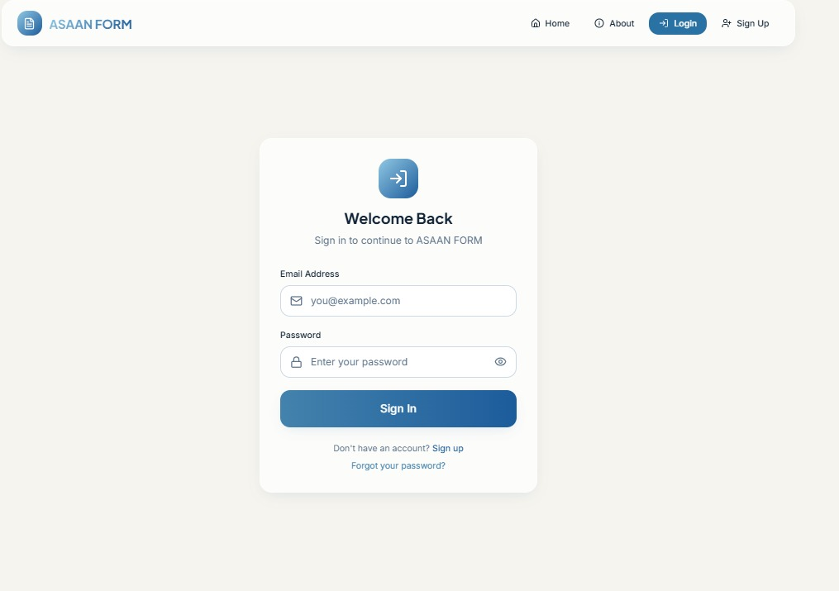
Figure 5. 1: Login Page

Signup Page
The Signup Page is used by new users to create an account in the system. It collects essential information required to create a secure user profile and connect the user to the appropriate role. For regular users, it helps in onboarding and registering their identity so they can begin uploading documents and completing forms immediately after registration.
The page is designed to be straightforward and easy to complete. Input fields are arranged in a logical order so that users can enter information without unnecessary confusion. This page is especially important because it expands accessibility and allows new users to join the system independently without requiring administrative intervention.
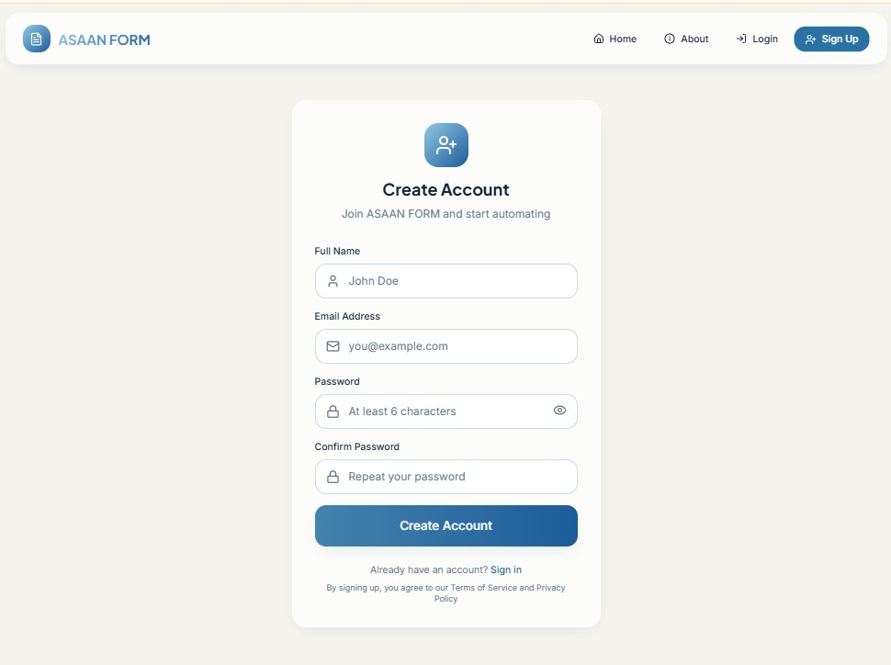
Figure 5. 2: Signup Page

About Page
The About Page introduces AsaanForm and explains its purpose, features, and overall mission. It gives visitors a brief understanding of how the platform simplifies form completion through AI-driven document extraction, bilingual text processing, and role-based dashboards. This page helps establish the identity and professionalism of the system.
The page is useful for new users, committee members, and evaluators because it summarizes the project in a clear and readable form. It also helps users understand how AsaanForm fits into the context of digital form automation and document processing before they interact with the actual system functions.
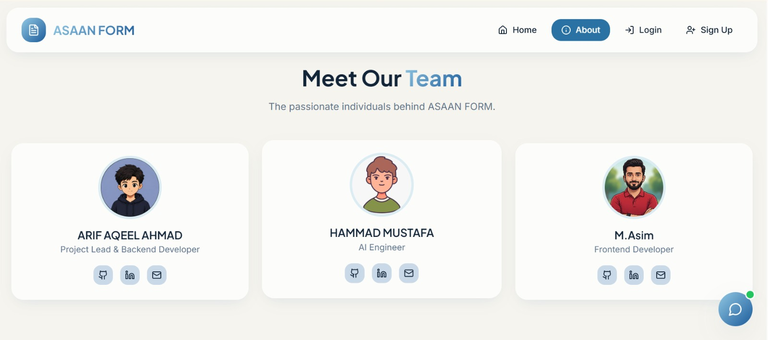
Figure 5. 3: About Page

Home Page
The Home Page serves as the landing page of AsaanForm and presents the platform in a welcoming and structured way. It introduces the core purpose of the system, highlights important features, and directs users toward login or other public pages. The page acts as the main entry point for visitors and provides a first overview of the application.
This page is important because it presents the project professionally and gives users a quick understanding of what AsaanForm offers. The home page also plays a role in navigation by connecting users to major sections of the system and setting the visual tone for the entire platform.
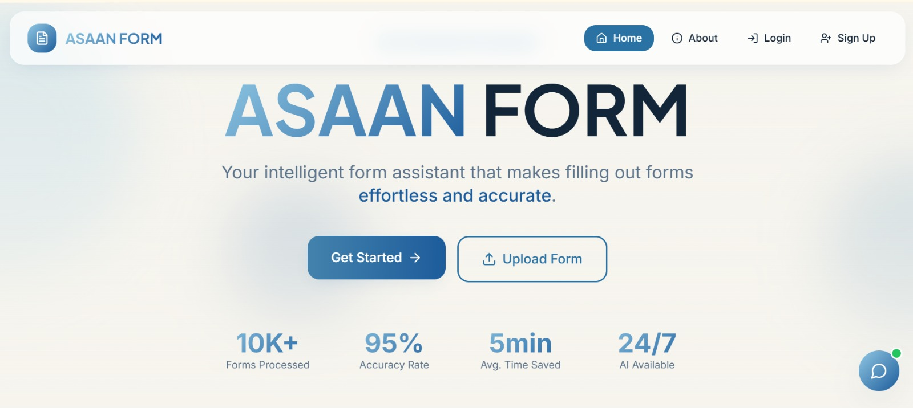
Figure 5. 4: Home Page

User Dashboard
The User Dashboard provides a centralized workspace where the user can manage form-related tasks, access uploaded documents, and handle form completion workflows efficiently in one place. It should present key activity summaries, recent submissions, and pending form tasks through an intuitive and organized interface. Quick access to document upload, form filling, and AI extraction tools must be available to minimize navigation time during active form processing sessions. The dashboard should also support customizable widgets so users can tailor the workspace to their individual workflow preferences.
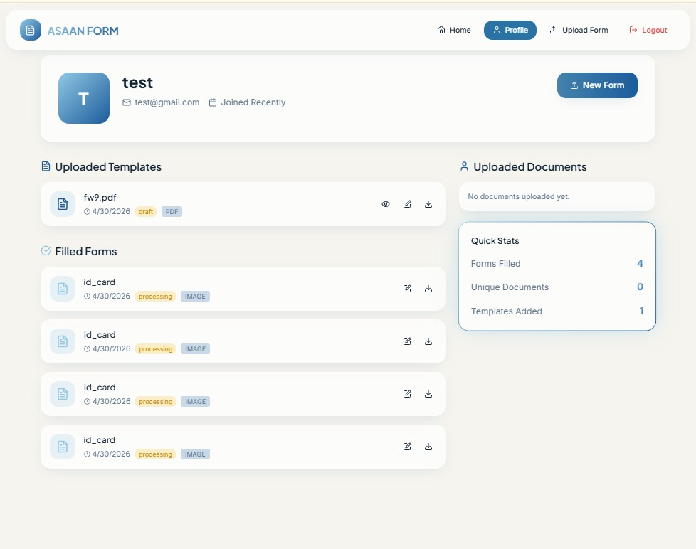
Figure 5. 5: User Dashboard

Upload Form Page
The Upload Document Page allows the user to upload identity documents and academic records so the system can process them and extract the relevant information for automated form filling. It should support multiple file formats including images and scanned documents and provide instant upload status feedback.
The Form Upload Page is used by the user to upload a target digital form so the AI agent can map the extracted document data into the correct form fields before the completed form is saved or exported. The page must ensure secure file transfer and display processing progress to the user.
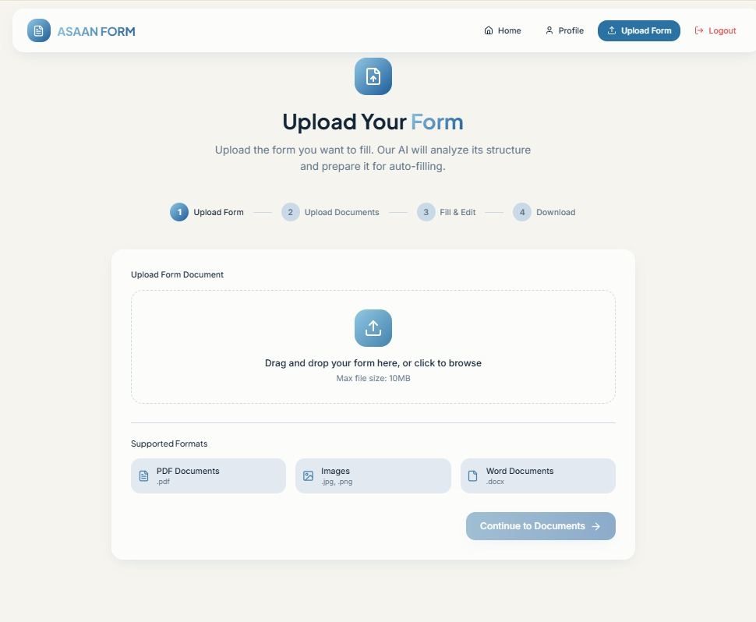
Figure 5. 6: Upload Form Page

Chatbot Page
The Chatbot Page provides an interactive AI assistant that answers user queries and offers quick guidance based on available document and form data. It should provide conversational support for common questions related to form filling, document processing, and platform navigation and guide users to the right features or resources. The chatbot must handle complex or unclear queries intelligently by reasoning over the available context and providing accurate and helpful responses when necessary.
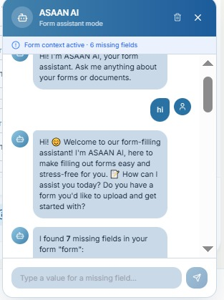
Figure 5.7: AI Chatbot Page

UI Design Summary
The user interface of AsaanForm reflects the goals of simplicity, accessibility, and role-based organization. Public pages introduce the platform, while authenticated dashboards provide structured access to features based on user type. The consistent layout across pages helps users feel familiar with the system, and the separation of responsibilities makes it easier to use and maintain.
Overall, the UI contributes strongly to the usability of AsaanForm because it connects technical functionality with a practical and human-centered presentation. The design supports both form automation workflows and evaluator expectations by making the project easy to understand, easy to demonstrate, and suitable for real-world use.

Chapter 6

Testing and Evaluation

Testing and Evaluation
This section covers the testing and evaluation processes performed on the AsaanForm platform to ensure all functionalities work as expected and meet the system requirements. It includes both manual and automated approaches to verify modules such as User Registration, Document Upload with AI Processing, Form Filling via Agentic AI, Bilingual OCR Extraction, and Chatbot Interaction. Comprehensive testing was conducted across all role-based dashboards to validate end-to-end workflows from authentication to AI-driven form completion and document data mapping.

Manual Testing
Manual testing involves verifying each feature of AsaanForm by executing test cases without automation. The tester interacts with the system, inputs data, and observes outputs to confirm correct behavior. All user actions, document uploads with OCR processing, AI-based field mapping, form submission workflows, chatbot interaction, and admin controls were checked for accuracy, reliability, and role-based security.

System Testing
System testing in manual mode ensures that the AsaanForm platform functions as a complete integrated system. Testers verified end-to-end workflows, including user registration and login, document upload with bilingual OCR processing, AI agent-based form field mapping, completed form export, chatbot queries, and admin monitoring. Role restrictions, extraction accuracy, and AI agent reasoning were also evaluated to confirm seamless performance under normal usage conditions.
Table 6.1: System Testing Results
Test No. | Test Case | Input | Expected Result | Actual Result | Status
1 | Login as User | Valid username and password | User dashboard opens | As expected, | Pass
2 | Login as Admin | Valid admin credentials | Admin dashboard opens | As expected, | Pass
3 | Register user via Signup | User details and valid email | User registered successfully | As expected, | Pass
4 | Upload CNIC for OCR | CNIC image (PNG/JPG) | Fields extracted and displayed | As expected, | Pass
5 | Upload transcript for OCR | Transcript image | Text extracted and saved | As expected, | Pass
6 | Upload target form | Digital form image/PDF | Form fields detected | As expected, | Pass
7 | AI agent maps fields | Extracted document data | Fields mapped accurately | As expected, | Pass
8 | View filled form | Logged-in user account | Completed form displayed | As expected, | Pass
9 | Use AI chatbot | Natural language question | Relevant response generated | As expected, | Pass
10 | View analytics as Admin | Dashboard access | Real-time metrics displayed | As expected, | Pass
11 | Export filled form | Completed form session | Form downloaded successfully | As expected, | Pass
12 | Bilingual OCR extraction | Urdu-English CNIC | Both scripts extracted correctly | As expected, | Pass

Unit Testing
Unit testing focuses on individual components of the Medrotic system, such as CNIC validation, document upload handlers, AI service calls, approval logic, and notification dispatch. Each module was tested separately to ensure correct outputs for given inputs.
Unit Testing 1: User Login
Testing Objective: To verify that the doctor login system functions correctly. The test ensures valid doctors access their dashboard and can quickly locate patients, while invalid credentials or CNIC formats are properly rejected.
Table 6.2: User Login
No. | Test Case ID | Test Case Name | Attribute and Value Tested | Expected Result | Actual Result
1 | UT-USR-001 | User Login (Valid) | Username: user123, Password: Pass123! | "User logged in successfully!" | Pass
2 | UT-USR-002 | User Login (Invalid) | Username: wronguser, Password: wrong | "Invalid credentials" | Pass
3 | UT-USR-003 | CNIC Upload (Valid) | PNG image of CNIC < 5MB | OCR extraction triggered | Pass
4 | UT-USR-004 | CNIC Upload (Invalid Format) | TXT file uploaded | "Unsupported format" | Pass
5 | UT-USR-005 | Empty Upload | No file selected | "Select a document to upload"

Unit Testing 2: OCR Extraction and Bilingual Processing
Testing Objective: To ensure the OCR engine correctly extracts text from uploaded documents and handles both Urdu and English content. The testing verifies accuracy of extracted text and proper handling of unreadable or low-quality images.
Table 6.3: OCR Extraction and Bilingual Processing
No. | Test Case ID | Test Case Name | Attribute and Value Tested | Expected Result | Actual Result
1 | UT-OCR-001 | Valid CNIC OCR | CNIC image (clear) | Text extracted correctly | Pass
2 | UT-OCR-002 | Bilingual Text Extraction | Urdu + English document | Both languages extracted | Pass
3 | UT-OCR-003 | Low Quality Image | Blurred image | Partial extraction with warning | Pass
4 | UT-OCR-004 | Low Quality Image | Blank image | No text detected | Pass

Unit Testing 3: Form Field Mapping and AutoFill
Testing Objective: To confirm that the LLM-based agent correctly maps extracted data into corresponding form fields. Incorrect or missing data is handled appropriately.
Table 6. 4: Form Field Mapping and Auto Fill
No. | Test Case ID | Test Case Name | Attribute and Value Tested | Expected Result | Actual Result
1 | UT-AI-001 | Valid Data Mapping | Name, CNIC, DOB extracted | Fields auto-filled correctly | Pass
2 | UT-AI-002 | Missing Field Handling | Missing address field | Field left empty with prompt | Pass
3 | UT-AI-003 | Incorrect Data Mapping | Misaligned text | Review required message | Pass
4 | UT-AI-004 | Multiple Documents | CNIC + Transcript upload | Data merged correctly | Pass

Functional Testing
Functional testing verified that the implemented features matched the functional requirements listed in the SRS. Each core requirement such as document upload, OCR extraction, bilingual processing, AI-based field mapping, and automated form filling were tested against the expected behavior. The results confirmed that the system behaves according to the approved design.
Functional Testing 1: User Workflow
Testing Objective: Verify user workflow from login to automated form completion.
Table 6. 5: User Workflow Functional Testing
No. | Test Case ID | Test Case Name | Attribute and Value Tested | Expected Result | Actual Result
1 | FT-USER-001 | Login + Document Upload | Valid login, CNIC upload | Document processed successfully | Pass
2 | FT-USER-002 | OCR + Data Extraction | Uploaded document | Extracted text displayed | Pass
3 | FT-USER-003 | Auto Form Filling | Extracted data | Form fields auto-filled | Pass
4 | FT-USER-004 | Error Handling | Invalid file upload | Error message displayed | Pass

Functional Testing 2: AI Processing Module
Testing Objective: Ensure AI-driven extraction and mapping works seamlessly.
Table 6. 6: AI Processing Functional Testing
No. | Test Case ID | Test Case Name | Attribute and Value Tested | Expected Result | Actual Result
1 | FT-AI-001 | Bilingual Document Processing | Urdu + English CNIC | Correct data extraction | Pass
2 | FT-AI-002 | LLM Field Mapping | Extracted attributes | Correct mapping to fields | Pass
3 | FT-AI-003 | Ambiguous Data Handling | Incomplete text | Prompt for user verification | Pass
4 | FT-AI-004 | Multiple Document Handling | CNIC + Transcript | Data combined correctly | Pass

Chapter 7

Conclusion and Future Work

Conclusion and Future Work
This chapter concludes the project and highlights future work for AsaanForm. It summarizes the overall achievements and the value delivered through the implemented system. It also reflects on the challenges faced during development and how they were addressed to meet project objectives. Finally, it outlines potential enhancements and long-term improvements to further strengthen the platform’s capabilities and scalability.

Conclusion
AsaanForm has been designed to revolutionize the way individuals interact with digital forms by automating the extraction and mapping of information from identity documents and academic records through an intelligent, AI-powered web application. The main goal of this project was to create a comprehensive form automation ecosystem where users can upload documents such as CNICs and academic transcripts, have their information extracted through a bilingual OCR pipeline, and have that information intelligently mapped into the correct fields of any target digital form, all within one unified and accessible system.
AsaanForm successfully eliminates the inefficiencies of manual form filling, repeated data entry, and the difficulty of processing documents that contain both Urdu and English text. Traditionally, users spent significant time re-entering the same personal information across multiple forms, often making errors due to language barriers or unfamiliarity with form structures. Now, AsaanForm provides instant document upload and processing, YOLO-based document region localization [9], bilingual OCR extraction using PaddleOCR [10], and LangChain-orchestrated [3] agentic field mapping that reasons over extracted content to fill forms accurately and efficiently.
The platform's role-based architecture ensures optimal usability across all stakeholders. Regular users benefit from streamlined document upload and form completion workflows with full AI assistance, while administrators achieve comprehensive oversight through user monitoring and platform analytics dashboards. The intuitive React-based interface requires no specialized training, making the system immediately accessible to Pakistani citizens, students, and professionals regardless of their technical background.
From requirement analysis through rigorous testing, AsaanForm's quality has been validated across all functional and non-functional requirements. Core modules including user registration, document upload with bilingual OCR processing, AI agent-based field mapping, chatbot interaction, form export, and admin analytics have been thoroughly tested for both typical usage scenarios and edge cases such as unsupported file formats, oversized documents, invalid input fields, and unauthorized access attempts. All test cases passed, confirming seamless integration between the FastAPI AI backend, Node.js web backend, React frontend, and hybrid data storage layer.
In conclusion, AsaanForm fulfills its mission of delivering a production-ready, AI-enhanced form automation system that significantly improves user efficiency, reduces manual effort, addresses the bilingual document challenge unique to the Pakistani context, and demonstrates the practical integration of computer vision, large language models, agentic AI, and modern web development into a coherent and scalable software solution.

Future Work
While AsaanForm successfully meets all current objectives and demonstrates production readiness, several strategic enhancements can further extend its capabilities and market applicability:

Mobile Application Development
Develop native iOS and Android applications using React Native or Flutter, providing offline access to previously filled forms and extracted document data, push notifications for form submission confirmations, camera integration for direct document capture and upload, and biometric authentication using Face ID or fingerprint recognition for enhanced security and convenience.

Multi Language and Regional Support
Expand language support beyond the current Urdu and English bilingual engine to include additional regional Pakistani languages such as Punjabi, Sindhi, and Pashto, with right-to-left text rendering improvements, localized date and identity number formats, and support for additional government-issued documents beyond the CNIC such as the NICOP and B-Form.

Advanced Analytics Dashboard
Develop institutional-grade analytics including form completion rate trends and user activity patterns, OCR accuracy tracking and continuous learning feedback loops, document type distribution analysis, and system performance metrics covering processing times and agent reasoning accuracy across varying document qualities and form complexities.

Multi-Language and Regional Support
Add Urdu language support alongside English, with right-to-left text rendering, localized date formats, regional hospital directories, and compliance with Pakistan-specific healthcare regulations (PMDC, DRAP standards)

References
1. T. Ramírez, “FastAPI Documentation,” Sebastián Ramírez / FastAPI, 2024. [Online]. Available: https://fastapi.tiangolo.com/ [Accessed: 2025].
2. LangChain AI, “LangGraph Documentation,” LangChain, Inc., 2024. [Online]. Available: https://langchain-ai.github.io/langgraph/ [Accessed: 2025].
3. LangChain AI, “LangChain Python Documentation,” LangChain, Inc., 2024. [Online]. Available: https://python.langchain.com/docs/ [Accessed: 2025].
4. Meta Open Source, “React Documentation,” Meta Platforms, Inc., 2024. [Online]. Available: https://react.dev/ [Accessed: 2025].
5. Redux Team, “Redux Toolkit Documentation,” Redux, 2024. [Online]. Available: https://redux-toolkit.js.org/ [Accessed: 2025].
6. Tailwind Labs, “Tailwind CSS Documentation,” Tailwind Labs, Inc., 2024. [Online]. Available: https://tailwindcss.com/ [Accessed: 2025].
7. OpenJS Foundation, “Node.js Documentation,” Node.js / OpenJS Foundation, 2024. [Online]. Available: https://nodejs.org/en/docs/ [Accessed: 2025].
8. MongoDB, Inc., “MongoDB Documentation,” MongoDB, Inc., 2024. [Online]. Available: https://www.mongodb.com/docs/ [Accessed: 2025].
9. Ultralytics, “YOLO Documentation,” Ultralytics, 2024. [Online]. Available: https://docs.ultralytics.com/ [Accessed: 2025].
10. PaddlePaddle, “PaddleOCR Documentation,” Baidu / PaddlePaddle, 2024. [Online]. Available: https://www.paddleocr.ai/ [Accessed: 2025].
11. DS4SD, “Docling Documentation,” IBM Research / DS4SD Project, 2024. [Online]. Available: https://docling-project.github.io/docling/ [Accessed: 2025].

